DASH: Desmopressin for reversal of Antiplatelet drugs in Stroke due to Haemorrhage

IRAS Project ID: 233744 CTA ref: 03057/0070/001-0001

Name of Researcher: ___________________________________________

Name of Participant: ___________________________________________

I confirm that I have been given a copy of the Patient Information Sheet (Version 1.0 dated 31 May 2018) and I agree that I /my relative or friend / this stroke patient (delete as appropriate)

- Will take part in the DASH study
- For my medical records to be accessed, blood samples to be taken and stored and brain scans used by the study team
- To be followed up at 3 months
- For my GP to be informed
- For my contact details to be collected and used for the purpose of the study
- For my confidential data to be used in further research analysis about ICH.

I understand that I am free to withdraw from the study at any point without giving a reason.
Patient consent – to be completed if participant has capacity to consent

______________________ ______________ ____________________

Name of Participant Date Signature

________________________ ______________ ____________________
Name of Person taking consent Date Signature

________________________ ______________ ____________________
Name of Witness if participant Date Signature
unable to physically sign

Personal or professional nominee consent - to be completed if participant does not have capacity to consent

________________________ ______________ ____________________
Name of Person giving Date Signature
nominee consent

Relationship to patient (please tick): Relative/carer/friend Healthcare Professional

______________________ ______________ ____________________

Name of Person taking consent Date Signature

Telemedicine used (please tick if Yes)

________________________ ______________ ____________________
Name of Witness if consent taken Date Signature
over the telephone

DASH Research Study – Information Sheet
Final version 1.5 10th Dec 2018
Does not contain
medicine

Contains medicine
What is this about?
- We want to know if you would like you to take part in a research study called DASH. DASH will test the effect of the drug called desmopressin that may stop bleeding by reversing the effect of blood thinning medication.
- Research staff will discuss the study with you and can answer any questions you may have. If you are not well enough we will try to ask your family or friend. If they are not present an independent doctor will decide for you on your behalf.
- Taking part in the study is voluntary; you don’t have to take part.

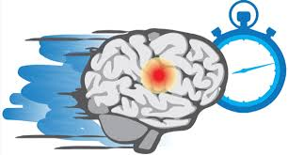 | Why are we asking you to take part in the study?  - You have had a stroke caused by bleeding in the brain and you have been taking blood thinning medication.
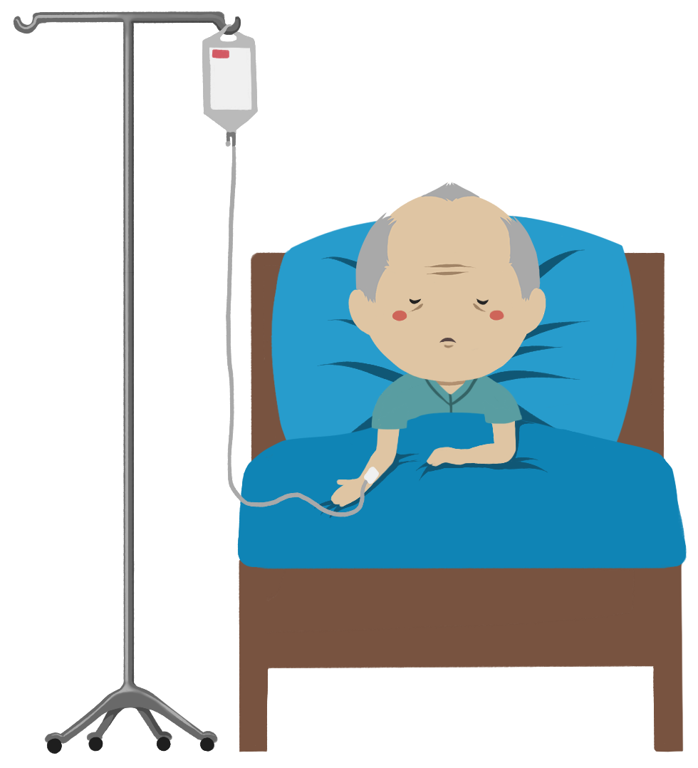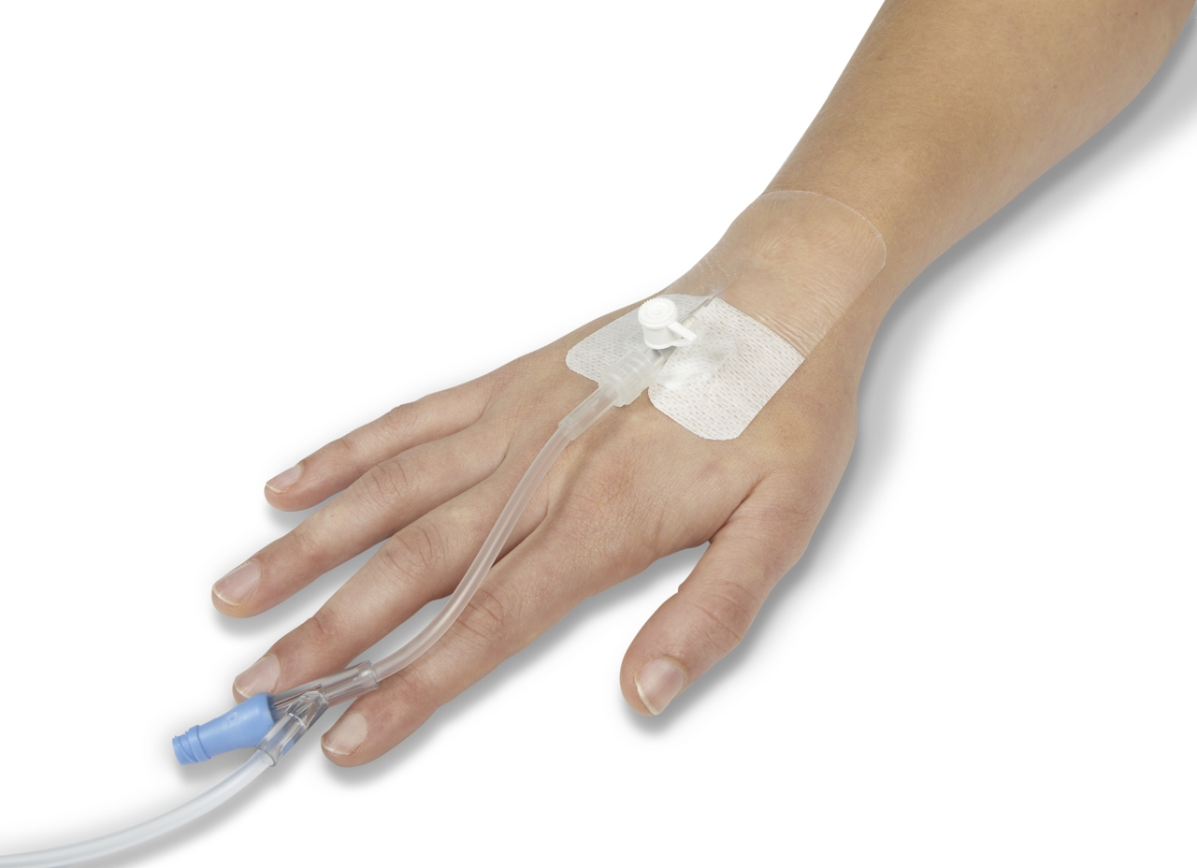  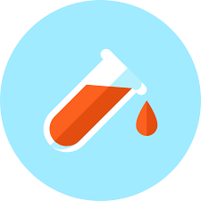  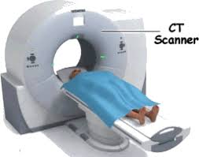 | If you take part:  - You will receive all the care and treatments you would normally receive.  - The medical team will give you a drip into your vein via a small needle, which takes 20 minutes.  - Half the people in this study will get a drip containing desmopressin and half will get a drip containing no drug (placebo).  - Which drip you are given is decided by chance (like flipping a coin). You won’t know which drip you will have been given.  - You will have three blood tests: one before the drip, one immediately after and another one on the next day to monitor results of the drip.  - You will have an extra head scan at some point in the next 2 days to monitor the bleeding. The study team will have copies of your brain scans.
Risks
The drug, desmopressin, has been given safely to thousand of patients with inherited bleeding problems.
- The drug can cause mild side effects: headache, nausea and vomiting, which can all be easily treated. Very rarely it can cause more serious sides effects and we will monitor closely for this.
- The extra head scan has around the same amount of radiation as living for a year in the UK.

90 days after your stroke:
- A researcher will call you to see how you are, if you have had any problems and how well you have recovered.
- If you are not well enough to talk we will try to ask your family, friend or GP.
During the study:
- If you have any questions then please ask.
- You may decide you do not want to take part at any time. This will not affect your care now or in the future.
- All the information we hold about you (including brain scans) will be kept in the strictest confidence.

