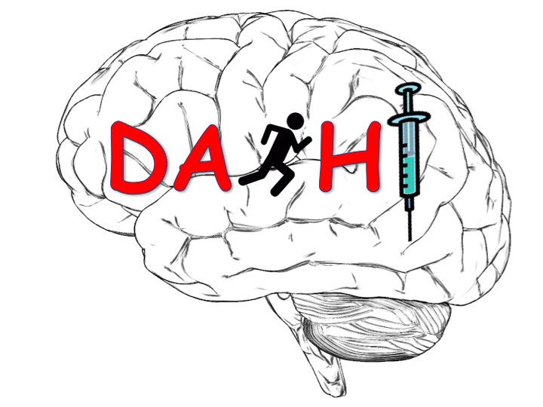

File Note

(IRAS Number: 233744)

DASH TRIAL NUMBER:
(in the format: C99/999/ZZ)

Details:

Actions:

Impact on Patient Safety:

Name (Signature) Date

Name (Print)

