MAnnitol for Cerebral oEdema after IntraCerebral Haemorrhage (MACE-ICH): a feasibility trial
IRAS Project ID: 1004870 CTA ref: 19162/0239/001-0001
Name of Researcher: ___________________________________________
Participant ID: ______________
Name of Participant: ___________________________________________
I confirm that I have been given a copy of the Legal Representative Information Sheet (Version _____ dated_______) and I agree that my relative / friend / stroke patient (delete as appropriate):
- Will take part in the MACE-ICH study.
- Will have extra blood samples taken and analysed and an additional head/brain scan performed and used by the study team.
- Will have their medical records accessed by authorised individuals from the Sponsor (Nottingham University Hospitals NHS Trust), the research group and the MHRA. I give permission for these individuals to have access to their records and to collect, store, analyse and publish information obtained from their participation in this study. I understand that their personal details will be kept confidential.
- Will be given a urinary catheter to monitor the effects of treatment in this study if required.
- Will receive a pregnancy test if deemed necessary because they are of a childbearing age (if appropriate).
- Will have their GP informed of study participation, who will be asked to provide information on their health status.
- For information held and maintained by the NHS Digital and other central UK NHS bodies to be used to help provide information about their health status.
- Will have their contact details collected and stored electronically and used for the purpose of the study.
- Will have their confidential data used in further research analysis about intracerebral haemorrhage (unless I raise an objection to this).
- May be approached to take part in other studies, and that data may be shared in accordance with the UK General Data Protection Regulation and Data Protection Act between the studies to reduce any burden on them. A list of other studies that your relative may also participate in (if they are eligible) is available on the study website: https://stroke.nottingham.ac.uk/mace-ich/.
In addition, I understand:
- My contact details will be stored in a secure system and may be used to contact me in the event that my relative / friend becomes uncontactable or incapacitated during the study and unable to provide six-month follow-up information themselves. I agree to provide this information on their behalf.
I understand that I can withdraw them from the study at any point without giving a reason.
 | What is this about?  - We want to know if your relative / friend / stroke patient would like to take part in a research study called MACE-ICH. MACE-ICH is a study testing the feasibility of giving a drug called mannitol, to patients with, or at risk of brain swelling following an intracerebral haemorrhage. This study is also investigating whether side-effects and complications of mannitol can easily be monitored, and whether participants can be followed up effectively in the future following their treatment.  - If the findings of this study show that giving mannitol, monitoring side effects or complications, and following up participants in the future, is feasible, a larger clinical trial using mannitol for the treatment of brain swelling after intracerebral haemorrhage may be conducted in the future.  - Research staff will discuss the study with you and can answer any questions you may have.  - Taking part in the study is voluntary; they do not have to take part.
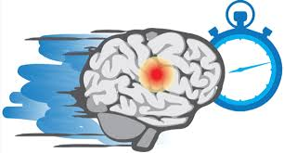 | Why are we asking them to take part in the study?  - They have had a stroke caused by bleeding in the brain and they have, or are at risk of having brain swelling.
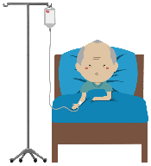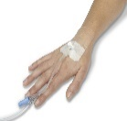  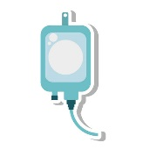  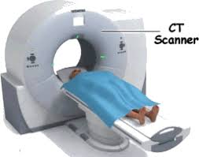 | If they take part:  - They will receive all the care and treatments they would normally receive.  - Randomly (like the roll of a dice), one-third of patients will get a single mannitol injection, one-third will get two mannitol injections and one-third will get standard medical care, which is all care and treatments they would normally receive.  - You will know which treatment they will be given.  - The medical team will give them the injection slowly into their vein via a small needle, which takes between 40 minutes to 100 minutes.  - They will have blood tests: one before the injection and one extra blood test the next day after treatment. If they receive two doses of mannitol, they will have a third blood test to monitor the results of the injection.  - To monitor the effects of the mannitol injection, they may have a urinary catheter, (a hollow tube) placed into the passage through which they normally pass urine (urethra). The catheter will be placed by a nurse or a doctor and the urine collected will be monitored. The catheter will be removed as soon as treatment is complete unless the treating doctor has another reason to keep it in longer.  - They will have an extra head/brain scan at some point in the next 5-7 days to monitor the bleeding and brain swelling. The study team will have copies of their brain scans.  - We will tell their GP that they are taking part in the study, and may contact their GP for information about their health.
 | Risks  The drug, mannitol, is being routinely given to patients with brain swelling after severe head injury or liver damage.  - The drug can cause side effects, such as increased urination, nausea, vomiting, fever, chills, headache, runny nose, chest pain, rash, dizziness or blurred vision. Rarely, it can cause more serious side effects and we will monitor closely for this.  - The urinary catheter may cause slight discomfort during placement and can cause infection in the bladder or kidneys. These types of infections are called urinary tract infections and usually need treatment with antibiotics. We will monitor closely for this.  - The extra head/brain scan has around the same amount of radiation as living for 10 months in the UK.
 | 6 months after their stroke:  - A member of the research team from Nottingham will call them to see how they are, if they have had any problems and how well they have recovered.  - If they are not well enough to talk, we will try to ask their family, friend or GP.  - We can also post the questions to them if they would prefer.
 | During the study:  - If you have any questions then please ask.  - You may decide you do not want them to take part at any time. This will not affect their care now or in the future.  - All the information we hold about them (including brain scans) will be kept in the strictest confidence.

Personal or professional legal representative consent

________________________ ______________ ____________________
Name of Legal Representative Date Signature

Relationship to patient (please circle): Relative/carer/friend Healthcare Professional

______________________ ______________ ____________________

Name of Person taking consent Date Signature

Telemedicine used (please tick as appropriate): Yes □
No □
Please tick to detail whether a witness is used for:
(i) Legal representative consent: Yes □ (ii) Telemedicine: Yes □
No □ No □
If a witness is used, please complete the witness information below

________________________ ______________ ____________________
Name of Witness Date Signature

3 copies: Original copy for participant, one for the researcher, one for the medical notes

