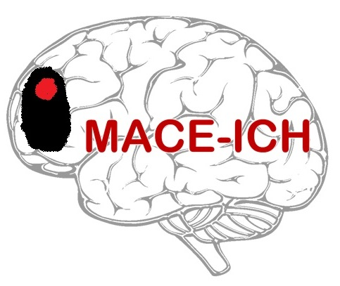
MAnnitol for Cerebral oEdema after IntraCerebral Haemorrhage (MACE-ICH): a feasibility trial
IRAS Project ID: 1004870 CTA ref: 19162/0239/001-0001
Name of Researcher: ___________________________________________
Participant ID: ______________
Name of Participant: ___________________________________________
I confirm that I have been given a copy of the Participant Information Sheet (Version _____ dated_______) and I agree:
- I will take part in the MACE-ICH study.
- For extra blood samples to be taken and analysed and an additional head/brain scan to be performed and used by the study team.
- For my medical records to be accessed by authorised individuals from the Sponsor (Nottingham University Hospitals NHS Trust), the research group and the MHRA. I give permission for these individuals to have access to my records and to collect, store, analyse and publish information obtained from my participation in this study. I understand that my personal details will be kept confidential.
- I will be given a urinary catheter to monitor the effects of treatment in this study if required.
- I will have a pregnancy test if deemed necessary because I am of a childbearing age.
- For my GP to be informed of my participation, who will be asked to provide information on my health status.
- For information held and maintained by the NHS Digital and other central UK NHS bodies to be used to help provide information about my health status.
- For my contact details to be collected and stored electronically and used for the purpose of the study.
- For my confidential data to be used in further research analysis about intracerebral haemorrhage (unless I raise an objection to this).
- For my legal representative to provide data on my behalf during the six-month follow-up if I become too unwell or uncontactable during the course of the study.
- If I lose the capacity to make decisions for myself during the course of the study, I’d be happy to continue in the study unless my legal representative raises an objection to this or I declare otherwise.
- I may be approached to take part in other studies, and data may be shared in accordance with the UK General Data Protection Regulation and Data Protection Act between the studies to reduce any burden on me. A list of other studies that I may also participate in (if I am eligible) is available on the study website: https://stroke.nottingham.ac.uk/mace-ich/.
I understand that I am free to withdraw from the study at any point without giving a reason.
 | What is this about?  - We want to know if you would like to take part in a research study called MACE-ICH. MACE-ICH is a study testing the feasibility of giving a drug called mannitol, to patients with, or at risk of brain swelling following an intracerebral haemorrhage. This study is also investigating whether side-effects and complications of mannitol can easily be monitored, and whether participants can be followed up effectively in the future following their treatment.  - If the findings of this study show that giving mannitol, monitoring side effects or complications, and following up participants in the future is feasible, a larger clinical trial using mannitol for the treatment of brain swelling after intracerebral haemorrhage may be conducted in the future.  - Research staff will discuss the study with you and can answer any questions you may have. If you are not well enough, we will try to ask your family or friend. If they are not present an independent doctor will be asked to decide for you, on your behalf.  - Taking part in the study is voluntary; you don’t have to take part.
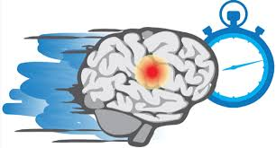 | Why are we asking you to take part in the study?  - You have had a stroke caused by bleeding in the brain and you have, or are at risk of having brain swelling.
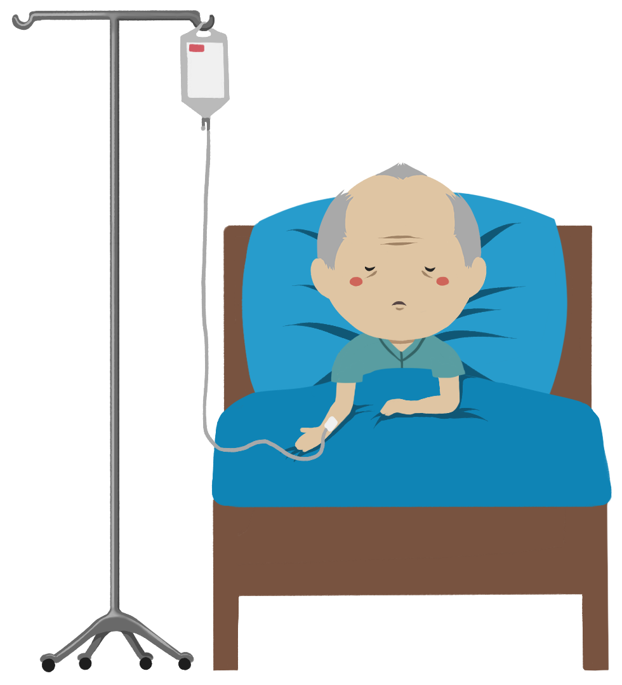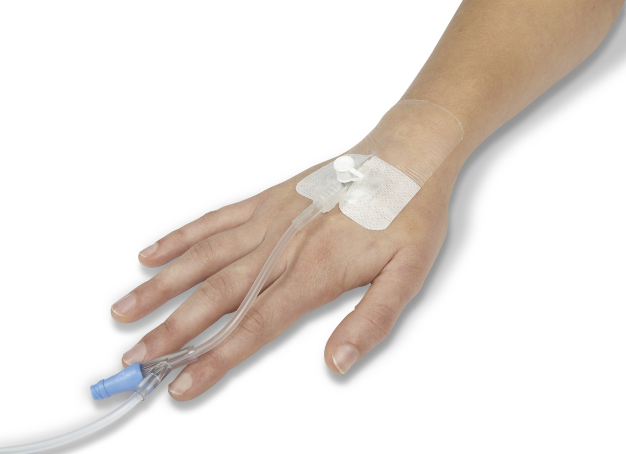  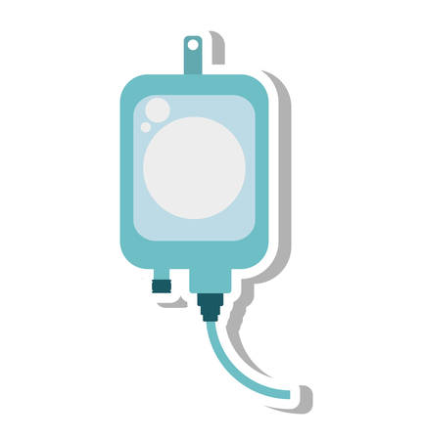  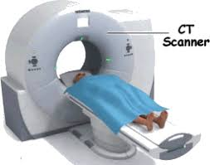 | If you take part:  - You will receive all the care and treatments you would normally receive.  - Randomly (like the roll of a dice), one-third of patients will get a single mannitol injection, one-third will get two mannitol injections and one-third will get standard medical care, which is all care and treatments you would normally receive.  - You will know which treatment you will be given.  - The medical team will give you the injection slowly into your vein via a small needle, which takes between 40 minutes to 100 minutes.  - You will have blood tests: one before the injection and one extra blood test the next day after treatment. If you receive two doses of mannitol, you will have a third blood test to monitor the results of the injection.  - To monitor the effects of the mannitol injection, you may have a urinary catheter, (a hollow tube) placed into the passage through which you normally pass urine (urethra). The catheter will be placed by a nurse or a doctor and the urine collected will be monitored. The catheter will be removed as soon as treatment is complete unless the treating doctor has another reason to keep it in longer.  - You will have an extra head/brain scan at some point in the next 5-7 days to monitor the bleeding and brain swelling. The study team will have copies of your brain scans.  - We will tell your GP that you are taking part in the study, and may contact your GP for information about your health.
 | Risks  The drug, mannitol, is being routinely given to patients with brain swelling after severe head injury or liver damage.  - The drug can cause side effects such as increased urination, nausea, vomiting, fever, chills, headache, runny nose, chest pain, rash, dizziness, or blurred vision. Rarely, it can cause more serious side effects and we will monitor closely for this.  - The urinary catheter may cause slight discomfort during placement and can cause infection in the bladder or kidneys. These types of infections are called urinary tract infections and usually need treatment with antibiotics. We will monitor closely for this.  - The extra head/brain scan has around the same amount of radiation as living for 10 months in the UK.
 | 6 months after your stroke:  - A member of the research team from Nottingham will call you to see how you are, if you have had any problems and how well you have recovered.  - If you are not well enough to talk, we will try to ask your family, friend or GP.  - We can also post the questions to you if you would prefer.
 | During the study:  - If you have any questions then please ask.  - You may decide you do not want to take part at any time. This will not affect your care now or in the future.  - All the information we hold about you (including brain scans) will be kept in the strictest confidence.

Patient consent

______________________ ______________ ____________________

Name of Participant Date Signature

________________________ ______________ ____________________
Name of Person taking consent Date Signature

Telemedicine used? (Tick as appropriate): Yes □
No □

Please tick to detail whether a witness is used for:
(i) Participant consent: Yes □ (ii) Telemedicine: Yes □
No □ No □
If a witness is used, please complete the witness information below

________________________ ______________ ____________________
Name of Witness Date Signature

3 copies: Original copy for participant, one for the researcher, one for the medical notes

