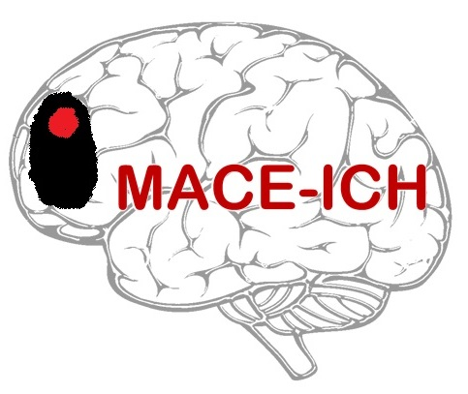

PARTICIPANT CONSENT FORM
(Version 2.0: date 27Jul2023)

Title of Study: MAnnitol for Cerebral oEdema after IntraCerebral Haemorrhage (MACE-ICH): a feasibility trial

R&I ref: 22SR001 IRAS ref: 1004870 CTA ref: 19162/0239/001-0001

Participant ID: _________________
Name of researcher: _______________________

Please initial box

Name of Participant: _______________________

- I confirm that I have read and understand the Information Sheet (version number ..……., date ……......…..…) for the above study and have had the opportunity to ask questions.

- I understand that my participation is voluntary and that I am free to withdraw at any time, without giving any reason, and without my medical care or legal rights being affected. I understand that should I withdraw then the information collected so far will not be erased and that this information may still be used in the project analysis.

- I understand that relevant sections of my medical notes (including clinical and imaging data) and data collected in the study may be looked at by authorised individuals from the sponsor (Nottingham University Hospitals NHS Trust), the research group at the University of Nottingham and the MHRA where it is relevant to my taking part in this study, in order to check that the study is being carried out correctly. I give permission for these individuals to have access to my records and to collect, store, analyse and publish information obtained from my participation in this study. I understand that my personal details will be kept confidential.

- I understand that my personal information will be stored, including electronically, for the purpose of this study. I understand that any information that could identify me will be kept strictly confidential and that no personal information will be included in the study report or other publication.

- I agree to have extra blood samples taken to monitor the effect of treatment given in MACE-ICH. I understand that samples will be destroyed after analysis.
N/A
Yes
- I understand that pregnancy would exclude participation and agree that a pregnancy test can be performed (if appropriate).

- I agree to have an extra brain scan to monitor the effect of treatment given in MACE-ICH.

- I understand that I may need, and I agree to a urinary catheter to monitor the effects of treatment given in MACE-ICH.

Page 1 of 2
- I understand that the information held and maintained by NHS Digital and other central UK NHS bodies may be used to help contact me, or a relative, to provide information about my health status.

- I agree to my GP, or any other doctor treating me, being informed of my participation in this study and to my GP providing information about my health status and contact details if needed.

- I understand that the information held and maintained by my GP and any other treating centres may be used to help contact me, or a relative, or to provide information about my health status.

- I agree to take part in the above study.
No
Yes

- If I become uncontactable or incapacitated during the course of the study and unable to provide information myself during follow-up, I agree for my legal representative, if available, to provide the follow-up information on my behalf (optional).
No
Yes

- If I lose the capacity to make decisions for myself during the course of the study, I’d be happy to continue in the study unless my legal representative raises an objection to this (optional).
Yes
No

- I agree for my confidential data to be used in further research analysis about intracerebral haemorrhage (optional).
No
Yes
- I agree to be approached about other research studies, and agree that any data collected from this study may be shared under the provisions of the General Data Protection Regulation and Data Protection Act, where this reduces any burden on me (optional).
No
Yes
- (i) I agree to receive a summary of the results once the trial has finished, by post and/or email, and I understand that my contact details will be retained for this purpose (optional).
Post
Email
N/A
(ii) If you have answered ‘yes’ to 16 (i), please indicate if you would prefer to
receive a summary of the trial results via post and/or email (optional).

______________________ ______________ ____________________
Name of Participant Date Signature

________________________ ______________ ____________________
Name of investigator taking Date Signature
consent

Telemedicine used? (Tick as appropriate): Yes
No

Please tick to detail whether a witness is used for:
(i) Participant consent: Yes □ (ii) Telemedicine: Yes □
No □ No □
If a witness is used, please complete the witness information below

________________________ ______________ ____________________
Name of witness Date Signature
Page 2 of 2

