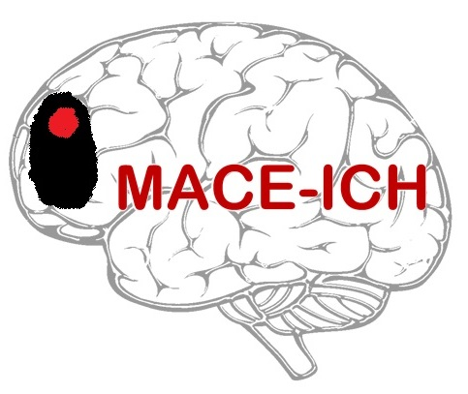

LEGAL REPRESENTATIVE CONSENT FORM
(Version 2.0: date 27Jul2023)

Title of Study: MAnnitol for Cerebral oEdema after IntraCerebral Haemorrhage (MACE-ICH): a feasibility trial

R&I ref: 22SR001 IRAS ref: 1004870 CTA ref: 19162/0239/001-0001

Name of researcher:
Participant ID: _________________

Name of Participant:

Your relative (it could also be a friend, someone you care for, or a stroke patient, but for brevity this document will use the term ‘relative’) is being invited to take part in a research study. Before you decide whether you agree to their participation it is important for you to understand why the research is being done and what it will involve. You have been provided with a copy of the information sheet. One of our team will go through the information sheet with you and answer any questions you have. Please talk to others about the study if you wish. Please ask us if there is anything that is not clear or if you would like more information.
Please initial box

- I confirm that I have read and understand the Legal Representative Information Sheet (version number ..……., date ……......…..…) for the above study and have had the opportunity to ask questions.

- I understand that my relative’s participation is voluntary and that I am free to withdraw them at any time, without giving any reason, and without their medical care or legal rights being affected. I understand that should they withdraw then the information collected so far will not be erased and that this information may still be used in the project analysis.

- I understand that relevant sections of my relative’s medical notes (including clinical and imaging data) and data collected in the study may be looked at by authorised individuals from the sponsor (Nottingham University Hospitals NHS Trust), the research group at the University of Nottingham and the MHRA where it is relevant to their participation in this study, in order to check that the study is being carried out correctly. I give permission for these individuals to have access to their records and to collect, store, analyse and publish information obtained from their participation in this study. I understand that their personal details will be kept confidential.

- I understand that my relative’s personal information will be stored, including electronically, for the purpose of this study. I understand that any information that could identify them will be kept strictly confidential and that no personal information will be included in the study report or other publication.

- I agree for my relative to have extra blood samples taken to monitor the effect of treatment given in MACE-ICH. I understand that samples will be destroyed after analysis.
N/A
Yes
Page 1 of 3
- I understand that pregnancy would exclude participation and agree that a pregnancy test can be performed (if appropriate).

- I agree for my relative to have an extra brain scan to monitor the effect of treatment given in MACE-ICH.

- I understand that my relative may need, and agree to them being fitted with a urinary catheter to monitor the effects of treatment given in MACE-ICH.

- I understand that the information held and maintained by NHS Digital and other central UK NHS bodies may be used to help contact my relative and I, to provide information about their health status.

- I agree to my relative’s GP, or any other doctor treating them, being informed of their participation in this study and to their GP providing information about their health status and contact details if needed.

- I understand that the information held and maintained by my relative’s GP and any other treating centres may be used to help contact my relative and I, or to provide information about their health status.

- In my opinion they would have no objection to taking part in the above study.
No
Yes
- I agree to the storage of my contact details in the event I am required to be contacted for the six-month follow-up data, on behalf of my relative. I understand that my contact information will be kept strictly confidential and that no personal information about me will be included in the study report or other publication (optional).
No
Yes

- I agree for my relative’s confidential data to be used in further research analysis about intracerebral haemorrhage (optional).
No
Yes
- I agree for me/my relative to be approached about other research studies, and agree that any data collected from this study may be shared under the provisions of the General Data Protection Regulation and Data Protection Act, where this reduces any burden on my relative (optional).
No
Yes
- (i) I agree to my relative receiving a summary of the results once the trial has finished, by post and/or email, and I understand that my relative’s contact details will be retained for this purpose (optional).
N/A
Post
Email
(ii) If you have answered ‘yes’ to 15 (i), please indicate if your relative would prefer to
receive a summary of the trial results via post and/or email (optional).

______________________
Name of Participant

______________________ ______________ _________ ____________________
Name of Legal Representative Signature Date Relationship to Participant
Page 2 of 3
________________________ ______________ ____________________
Name of investigator taking Date Signature
consent

Telemedicine used? (Tick as appropriate): Yes
No

Please tick to detail whether a witness is used for:
(i) Legal representative consent: Yes □ (ii) Telemedicine: Yes □
No □ No □
If a witness is used, please complete the witness information below

________________________ ______________ ____________________
Name of witness Date Signature
Page 3 of 3

