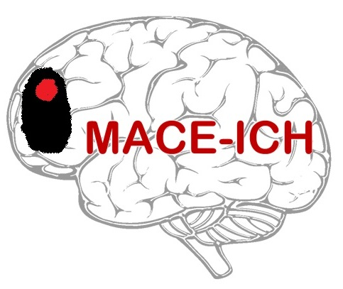



**MAnnitol for Cerebral oEdema after IntraCerebral Haemorrhage (MACE-ICH)**

**File Note**

**MACE-ICH Trial Number**: ____________________________________

(in the format: C999/999)

**Details:**

**Actions:**

**Impact on Patient Safety:**

**Impact on Compliance:**

Name (Signature) Date

Name (Print)