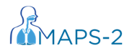

File Note

(IRAS Number: 290474 )

MAPS-2 Trial Number: ISRCTN 40512746

Details:

Actions:

Impact on Patient Safety:

Name (Signature) Date

Name (Print)

