**Reminders:**

* **Patient is blinded of the treatment: they should not know the treatment they are in.**
* **Treatment is either Metoclopramide or Saline (NaCl 0.9%) so must be of same amount: 2mls**
* **Prescription will state if the patient is randomised to Metoclopromide treatment or Saline placebo**
* **If NG in-situ then administration should be via the NG using either Metoclopromide IV or saline.**
* **Administration should be done by ASU nurses, trained by the Stroke Research Nurses or Band 6s.**
* **Any queries please contact the Stroke Research Nurses - Bleep: 7540 / Ext: 4120, 4121 (Normal working hours). If out of hours please speak to the Nurse-in-Charge.**

What you would need:

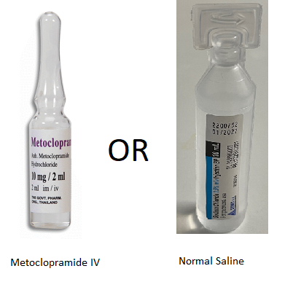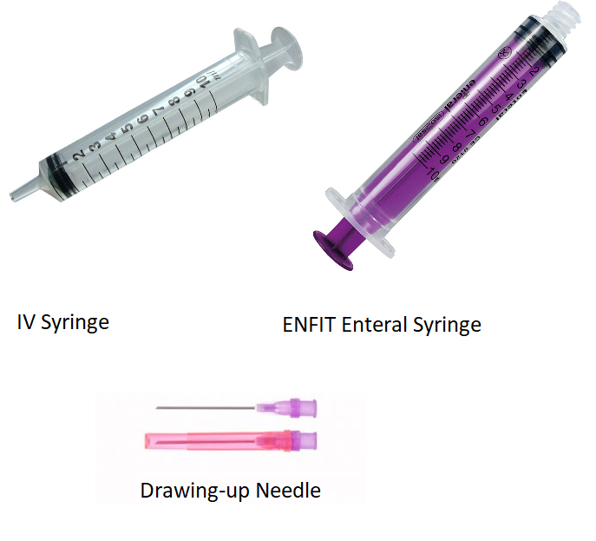

Procedure:

* Is there Nasogastric Tube in situ?

Yes: administration is via NG Tube

No: administration is via IV Cannula

NG Tube:

1. Draw up 2 mls of either Metoclopramide IV or Saline using syringe and drawing up needle.
2. Using the ENFIT enteral syringe, flush the NG tube with 10 mls of water.
3. Transfer the drawn-up solution (either Metoclopramide or Saline) to the ENFIT enteral syringe.
4. Administer via NG tube
5. Flush NG tube with 10 mls water.

IV Administration:

1. Draw up 2 mls of either Metoclopramide IV or Saline using syringe and drawing up needle.
2. Flush 10 mls Saline into the IV cannula
3. Administer the drawn-up solution (either Metoclopramide or Saline) via IV cannula
4. Flush 10 mls Saline into the IV cannula