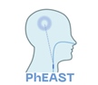

**File Note**

**PhEAST**

**PhEAST**: __________________________________

(in the format: C999/9999/Z-Z)

**Details:**

**Actions:**

**Impact on Patient Safety:**

Name (Signature) Date

Name (Print)