PhEAST Working Practice Document
Title: Document Prep and Upload, No. 009
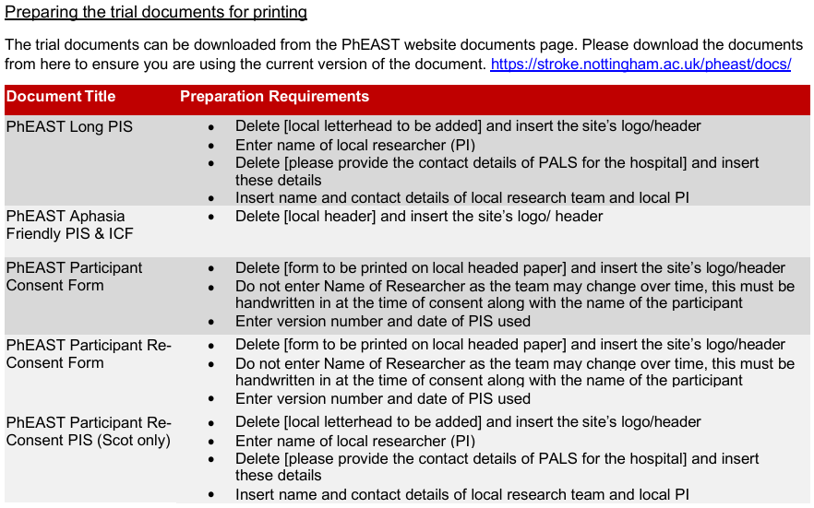

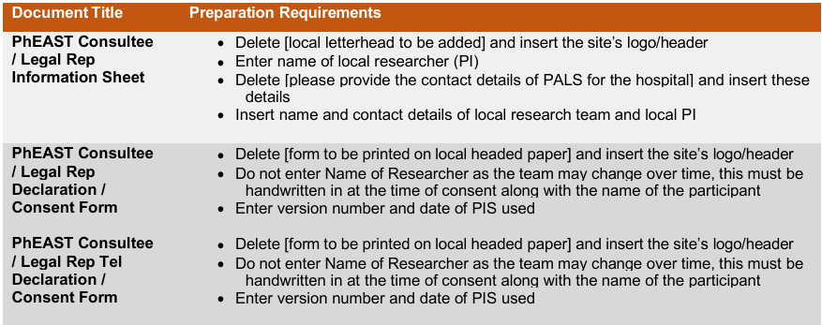

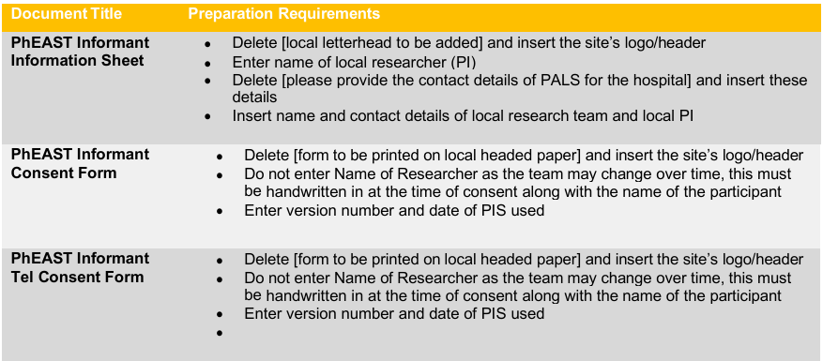

Note: remember when the participant completes the written follow on consent the boxes need to be initialled by the participant (if they have capacity to do do). Please do not tick the boxes.
GP Letter
After a participant has been enrolled into the PhEAST trial you will need to send a letter to their GP informing them of their patient's participation in the trial.
Preparing the template: Delete [form to be printed on local headed paper] and insert the site’s logo/header. Insert the local research teams contact details.
Do not print GP templates, the letters will be specific for each participant. When completing the GP letter please enter
- Date letter is typed
- GP address
- Name of GP
- Name of patient
- DOB of patient
- Name of local PI, job title and signature
Do not forget to include a copy of the participant information sheet to be sent with the letter.
Please save the letter to the participant's medical records as well as their CRF.

Documents ready for enrolment
Once you have localised the above documents, we recommend you print a small batch of each document ready for the consent process and make sure all the local team know where these documents are stored. Please make sure you are using the most up to date version before consenting the participant.

