**PhEAST – Working Practice Document**

**Title: Secure Vault Uploads, No. 010**

**Introduction:**

The purpose of this Working Practice Document (WPD) is to describe the procedure to be used by site investigators for the management of uploads to the secure vault. The WPD applies to the PhEAST trial coordinated by the Stroke Trials Unit.

**Accessing the secure vault:**

The secure vault is used for sites to upload the required anonymised and non-anonymised documentation relating to participants in the PhEAST trial.

On randomising a participant, the investigator will be prompted to access the secure vault in order to enter participant contact details for the day 90, 180 and central follow-ups (see screenshot on next page).

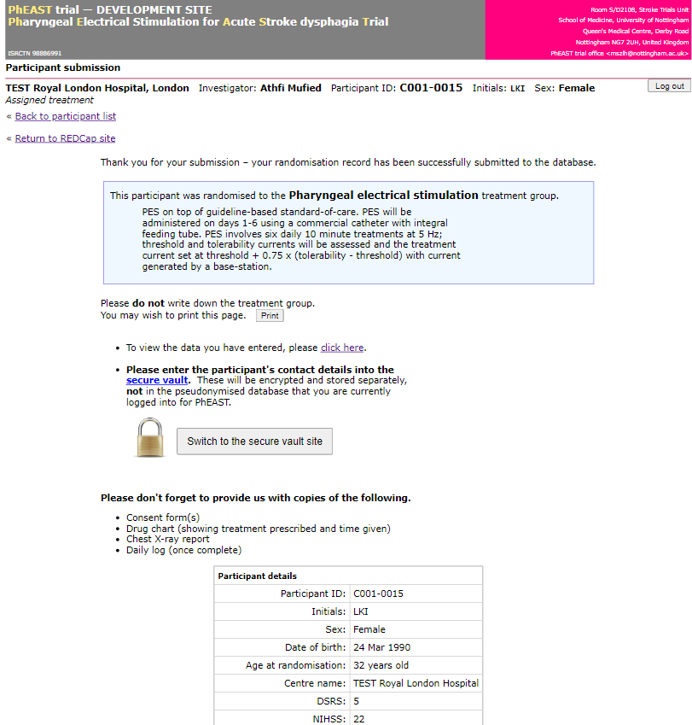

The secure vault can also be accessed at any time through the PhEAST database. Once the participant list is selected, a screen similar to the screenshot below will be shown.

In the column titled “contacts/documents”, confirmation of the uploaded documents is indicated by the Y/N and relates to: follow-up contact details, consent form(s), GP letters, file notes, SAE forms. In this column, the investigator should select the link for the relevant participant and the next page will display a link to log into the secure vault.

**Uploading to the secure vault:**

The secure vault should be used to upload both anonymised and non-anonymised documents for participant’s enrolled into the PhEAST. Non-anonymised documents will be encrypted and stored separately.

As part of the ongoing monitoring throughout the duration of the trial, the following paperwork should be uploaded to the secure vault when a participant is recruited to the trial and will be reviewed by the coordinating centre:

* Consent forms (including informant consent forms).
* Participant contact details (for follow-ups).
* GP Letters.

**Please do not send any patient identifiable documentation to us via email or fax.**

Upload Process:

1. On the participant list page, hovering over the YY/NNN will show what is still required to be uploaded for that particular participant. After clicking on the link, you will be presented with the screen below.

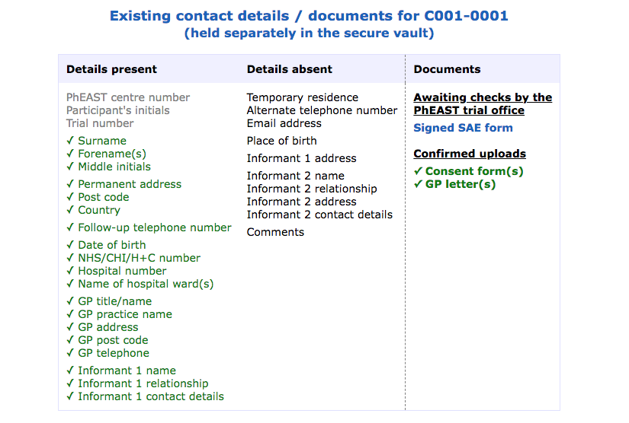

1. This page will show you in more detail what has been uploaded for that participant as well as which contact details have been completed:

* Required/expected documents will remain red until uploaded.
* Documents that have been uploaded by the site but are awaiting checks from the trial office will be blue.
* Documents that have been uploaded by the site and checked by the trial office will be marked as green and ticked.

1. To upload a document, please select the document type (or use the ‘multiple document types’ option if you have a mix of documents in one file) from the drop down box and click on the link to ‘Switch to the secure vault site’.
2. Click ‘choose file’, select the file from your computer files and click ‘upload file’.
3. From this page, you can also scroll down further to see the documents that you have already uploaded for that particular participant and whether they have been reviewed by the trial office yet.
4. Files must be uploaded in one of the following formats: PDF, JPEG, PNG, or GIF. If the document you are attempting to upload is currently in another format such as Word, you should go to your original document and select the ‘print to PDF’ option and save, this will convert the document to a PDF which you will then be able to upload.
5. On selecting the contact details, you will be able to enter the participant’s contact details straight into the database.
6. Once all required/expected documents have been uploaded and reviewed, the trial office will be able to lock the secure vault.

**Required Documentation:**

**Please ensure that the documents listed below are uploaded to the secure vault within 7 days of completion.**

Written Consent Form:

The consent form should meet the following requirements:

* Printed on local headed paper.
* Correct version number and date of information sheet added
* Participant name and signature clearly visible.
* Personal legal representative name and signature clearly visible (if applicable).
* Personal consultee or independent physician name and signature clearly visible (if applicable).
* Name and signature of authorised individual receiving consent clearly visible (code J on delegation log).
* If consent obtained via telemedicine, the participant (or consultee/legal representative) should sign the form as well as the witness, and should be signed by the individual taking consent on their return to the hospital.
* Boxes have been **initialled** and not ticked.
* Signatures are dated.
* The consent form should be labelled with the participant ID.

Contact details for central follow-ups:

The following information should be provided by sites:

1. Forename and Surname.
2. Date of Birth.
3. Permanent address.
4. Follow-up telephone number.
5. An alternative telephone number/address/email-address of a relative or carer.
6. Hospital number (NHS / CHI).
7. GP practice address and telephone number.
8. Informant contact details.

File notes:

* Participant-specific file notes should be uploaded to the secure vault.
* Please use the PhEAST file note template which can be downloaded from the trial’s documents page: https://stroke.nottingham.ac.uk/pheast/docs/
* File notes must be anonymised, with the participant ID documented.
* Please provide a detailed description of what happened, what actions were taken and the impact on participant safety.
* Please ensure that the file note is signed and dated prior to upload.

SAE forms:

* Paper SAE forms signed by the local PI should be uploaded to the secure vault.
* SAE forms must be anonymised, with the participant ID documented.

GP Letter:

* Paper GP letters should be uploaded to the secure vault
* Please write the participant ID on the form and anonymise the participant name / DOB