PhEAST Working Practice Document
Title: Cognition Sub-study, No. 011

Embedded into the PhEAST protocol is the PhEAST cognition sub-study. This is part of the main protocol and is not an optional sub-study.

Post-stroke cognitive impairment (PSCI) and post-stroke dementia (PSD) follow stroke damage to cognitive neural pathways and/or the presence of concomitant small vessel disease and are common with rates up to 35% at 5 years. However, studies into PSCI/PSD are complicated by multiple issues, notably: a tendency to recruit patients with milder stroke (who are easier to enrol); assessment of cognition in the presence of existing cognitive impairment or concurrent dysphasia; difficulty in follow up, e.g. because the patient is in a care home; or the patient has died. As a result, adequate assessment of cognition and its temporal trajectory in patients with severe ischaemic stroke (IS) or intracerebral haemorrhage (ICH) is often not performed.

This working practice document is a tool to assist with performing all of the assessments required for the cognition sub-study.

Cognition CRF

The cognition CRF contains all of the questions for the PhEAST trial participant. This can be downloaded from:

https://stroke.nottingham.ac.uk/pheast/docs or from REDCap directly.

The cognition CRF is completed at both day 000 (can be done before or after randomisation, but if completed after randomisation please ensure this is done as soon as possible after) and at day 14 by the site.

The central trial team will then complete this again at day 90, 180 and day 365.

The CRF will ask you the participant’s level of aphasia, if the participant is mute or unresponsive (scores a 3) they will not be able to answer the cognition questions, and you can click ‘skip filling the form’ and mark it as complete.

If the participant has mild to moderate or severe aphasia (scores a 1 or 2) then please attempt the cognition questions with the participant, and see which bits they can do.

If the participant has no aphasia (scores a 0) please attempt the cognition questions with participant.
The cognition CRF contains scales from: 4AT (test for delirium), the Brief Fatigue Inventory, the Patient Health Questionnaire, the Generalised Anxiety Disorder scale, the Clinical Frailty Score, Clinical diagnosis of dementia & limited care-home admission (from the R4VaD study), the Zung Depression Scale, the Stroke Impact Scale, the MoCA, the TICS and Free Cog Questions.

Please complete as much as you can with each participant.

All questions are to be completed face to face (even if it is a telephone scale).

Please input the assessor information at the bottom of the screen.

If the participant has had any of the scales done clinically within a recent time period, you can use these instead of asking the participant again.

Please input at the bottom of the form whether any information is missing, and if so, why it is missing (participant fatigued, participant unable to answer due to aphasia, etc).

IQCODE CRF

The IQCODE CRF contains all the questions for the PhEAST trial participant’s informant. Please attempt to get an informant for every PhEAST trial participant. The latest form can be downloaded from:

https://stroke.nottingham.ac.uk/pheast/docs or from REDCap directly.

An informant can be the NoK, partner / spouse, son, daughter, other relative, please see flow chart below on how to consent an informant:
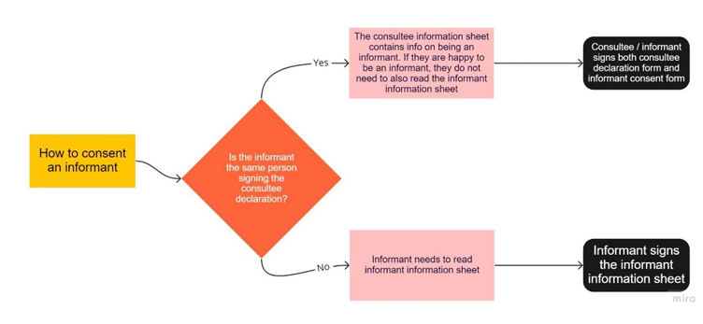

Once you have consented an informant, please upload the consent form to the secure vault, in the same way you would upload the main consent form.

Please document on the IQCODE CRF whether an informant has been consented or not, and their relation to the participant.

The IQCODE CRF contains scales from: Informant Questionnaire on Cognitive Decline in the Elderly (IQCODE), the 4AT (test for delirium), the Neuropsychiatric Inventory, Questionnaire Version (NPI-Q) and the Lawton Activities of Daily Living (ADL).

The CRF can be completed over the telephone, or a postal CRF can be sent as well as doing this face to face.

If no informant consent is taken or they decline please still provide information for a NoK (name, phone number, address) on the contact details form. Please make them aware that even though they have declined the informant consent they may still be contacted by the coordinating centre at day 90, 180 and 365 to complete the main follow up on behalf of the patient if required.

