PhEAST Working Practice Document
Title: Randomisation, no. 012

Patients who consent (individually, or by personal/professional legal representative) to participate in the trial will be randomised by a member of their local research team within 2 to 31 days of stroke onset. Randomisation is done via bespoke, secure web-based system, maintained by the central Stroke Trials Unit in Nottingham.

Randomisation FAQs:

Q: What if we’re unable to obtain certain data points?
A: Please click the ‘M’ symbol next to the question, and click not done or not known. If there is a not an ‘M’ symbol next to it, this information is required in order to proceed to randomisation

Q: Which forms need completing prior to randomisation?
A: Eligibility, Day 000, Day 000 Clinical and Day 000 EQ-5D-5L – please complete Day 000 cognition and Day 000 IQCODE as close as possible to randomisation (if incomplete this will not stop randomisation, but we like them to be done as close together as possible)

Q:Who can randomise?
A: Anyone who is delegated to do so on the log. Ensure it’s not someone who will be completing blinded follow ups, as the randomisation result will blind them.
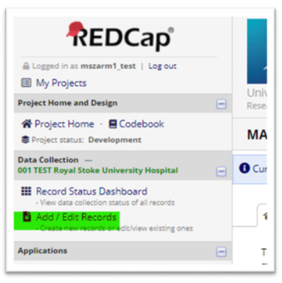
- You will need to login into REDCap and then select the ‘PhEAST’ project. Once you’re in PhEAST REDCap, head towards the column on the left-hand side of the page and select ‘Add/Edit Records’

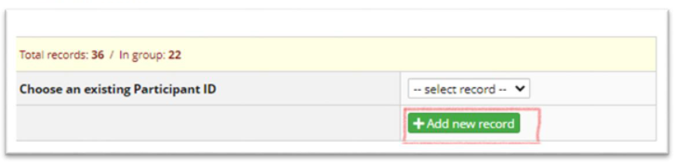
- Then proceed to ‘Add new record’.

- In the new data entry, select ‘Eligibility’ and then complete this form.
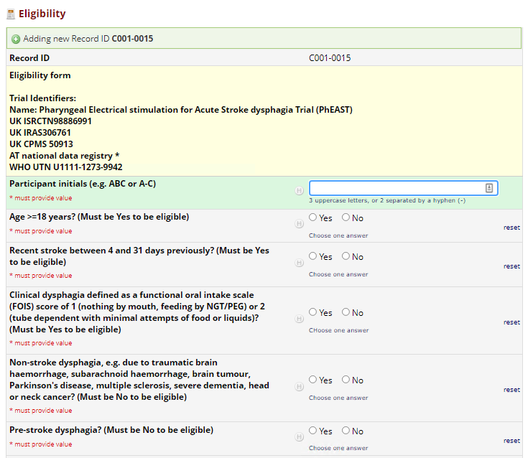
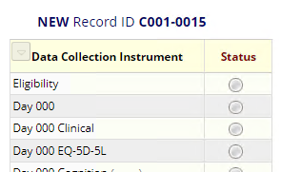

- Once complete, click ‘Save & Exit Form’
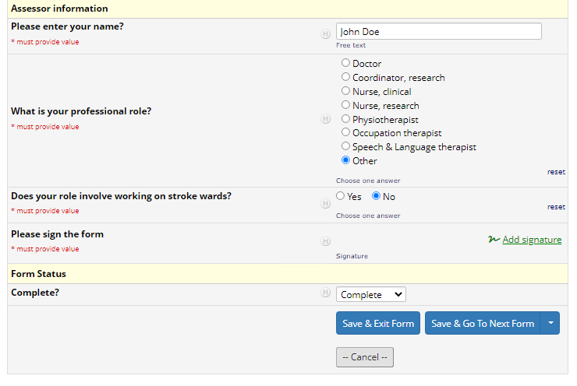

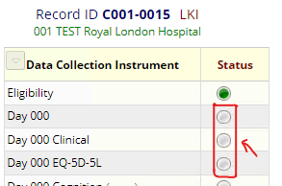
- Repeat steps 3-4 for ‘Day 000’, ‘Day 000 Clinical’ and ‘Day 000 EQ-5D-5L’ forms. Once all these 4 forms are complete on the picture you can move onto the next step.

- Head back towards the left-hand side of the page and click the ‘Randomisation’ link under ‘Project Bookmarks’
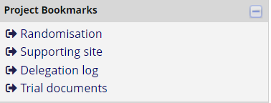

- Check the information in the randomisation summary and then click ‘Randomise this participant’.
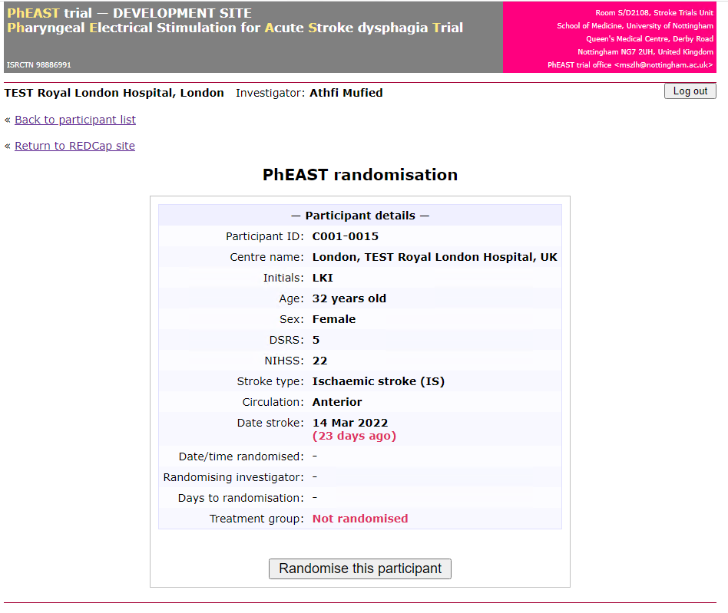

- Once complete, the following page should appear on your screen. Please click the link to get to the ‘Success page’
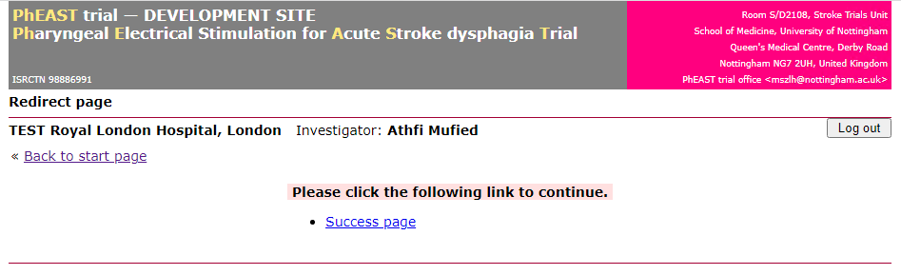

- The next page should be displayed, which shows a summary of all the participant’s randomisation information. This shows:
- Participant’s trial ID number
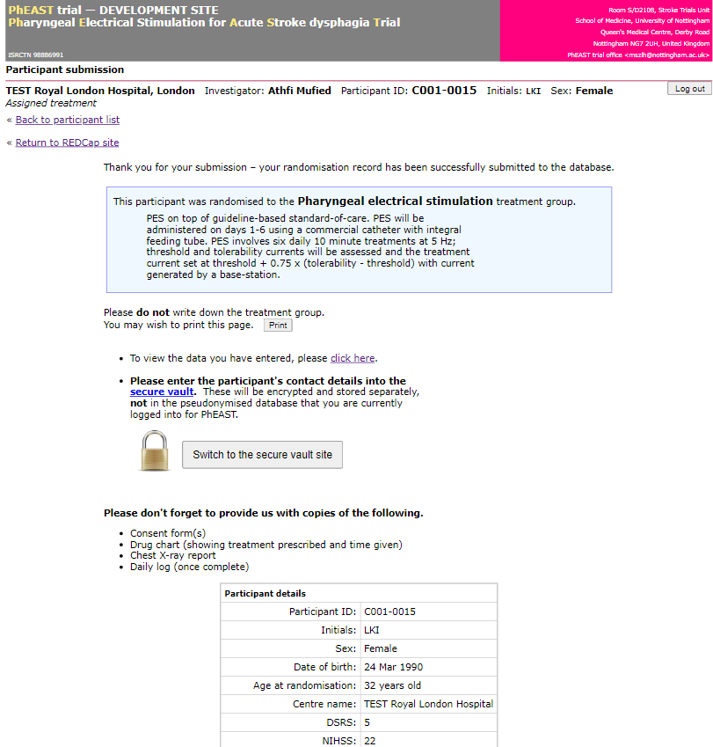
- The name of the randomising investigator
- Participant’s allocated treatment arm.

- Click into the secure vault site to enter the participant’s contact details, which will be required for follow-up.

- Identifiable data will be kept separately in the secure vault, whereas all other data will be kept in the REDCap database. For more information on the secure vault process please see WPD 010 Secure Vault Uploads.

