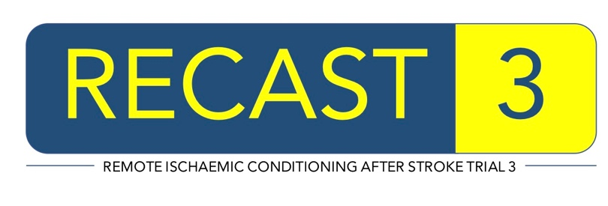


File Note

RECAST-3 - Remote Conditioning After Stroke Trial-3

RECAST-3 Trial Number: ____________________________________
(in the format: C999/9999/Z-Z)

Details:

Actions:

Impact on Patient Safety:

Name (Signature) Date

Name (Print)

