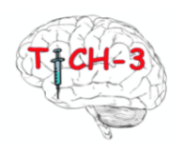

PARTICIPANT SHORT INFORMATION SHEET FOR RELATIVES

(Final Version 1.1 24/03/2023)

Title of Study: TICH-3 EU CTR Number: 2022-500587-35-01

Name of Researcher:

Name of Participant:

    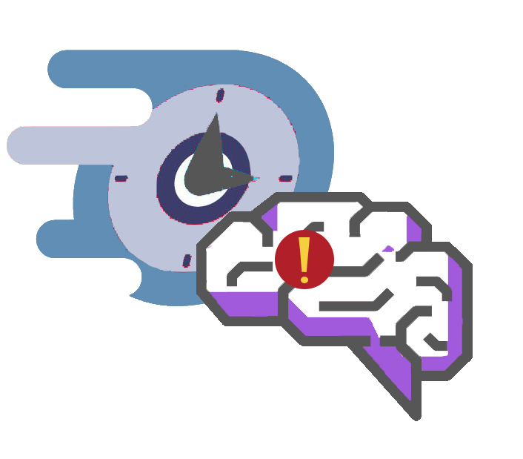 | What is this about?  - We want to know if you would like your relative to take part in a research study to test a drug called tranexamic acid  - Taking part in the study is voluntary- your relative does not need to take part  Why are we asking your relative to take part in this study?  - Your relative has had a stroke caused by bleeding in the brain this is known as intracerebral haemorrhage (ICH).  - Stroke is an emergency – it is important that treatment is given as soon as possible  What is the study testing?  - We want to know if the drug tranexamic acid reduces the bleeding in this type of stroke and may reduce the severity of injury caused by the stroke.  - Tranexamic acid is approved for use in other emergency medical conditions to stop bleeding but we do not know for certain if it helps recovery after stroke due to bleeding in the brain.
    PLACEBO  TRANEXAMIC  ACID | If your relative participates: study treatment  - Your relative will receive all the care and treatments for stroke they would normally receive.  - The study will also involve giving you a drip for 8 hours. This will contain tranexamic acid or no drug, known as placebo.  - Which drip your relative is given is decided by chance (like flipping a coin) – this is called randomisation  - Because bleeding is an emergency and needs speedy treatment, after the brain scan, we will ask for verbal permission and then ask for written consent afterwards.
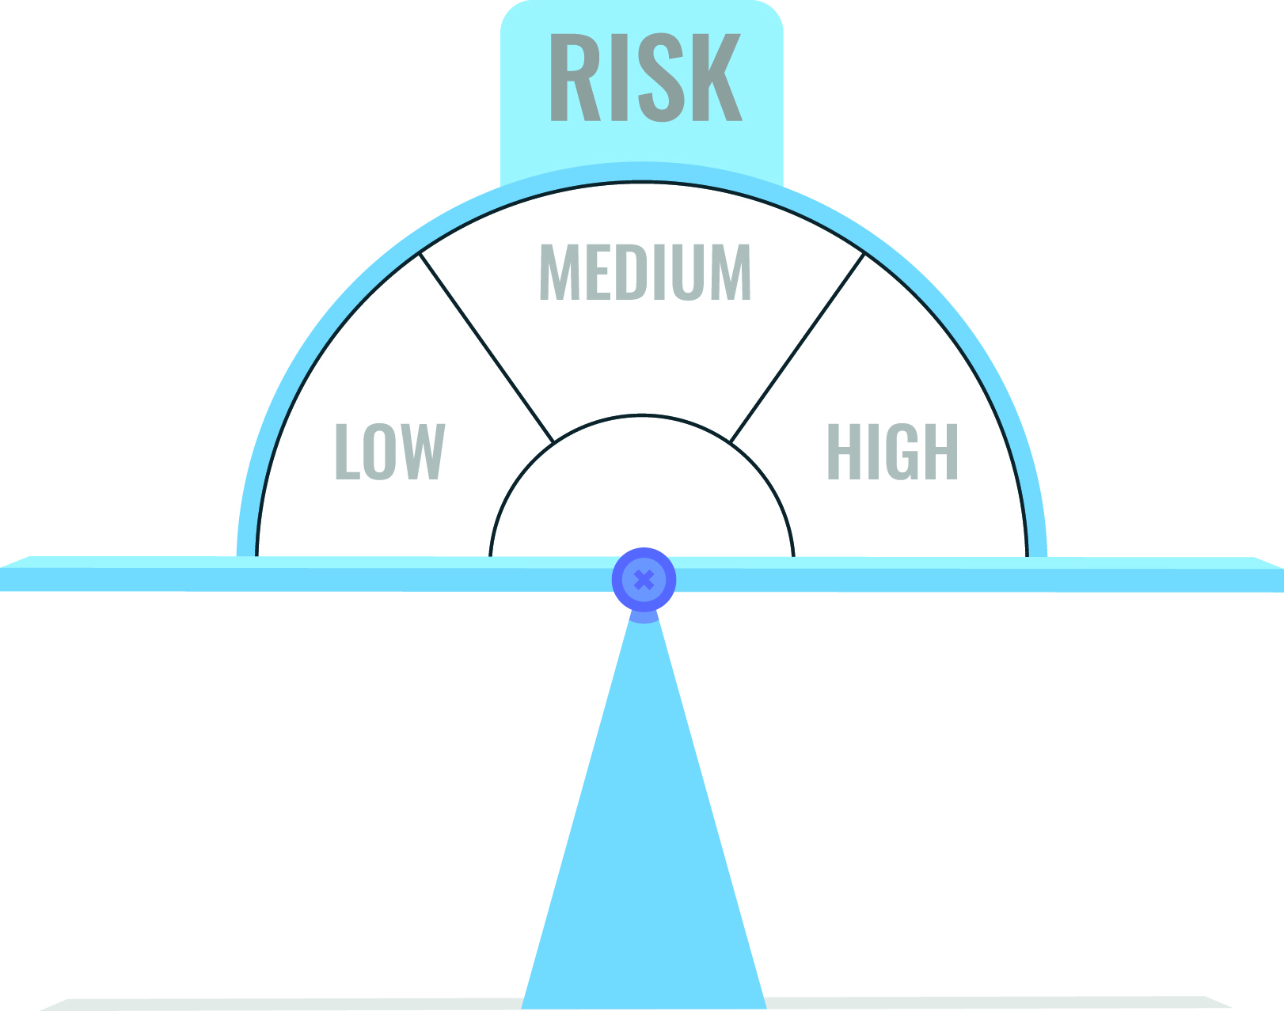 | Risks  - Tranexamic acid is used in other emergency medical conditions to stop bleeding and appears safe  - Mild side effects: diarrhoea, low blood pressure and dizziness - all can be easily treated.  - Very rarely, but more serious side effects could be blood clots in the legs (DVT) or lungs (PE) but we will monitor very closely for this.
 | 180 days after your stroke:  - Your relative will receive a questionnaire in the post asking how you are.  - If your relative cannot complete the questionnaire by themselves, a researcher can call them to complete it together  - If your relative is not well enough to talk, we will ask you or other family relative or GP to complete the questionnaire.
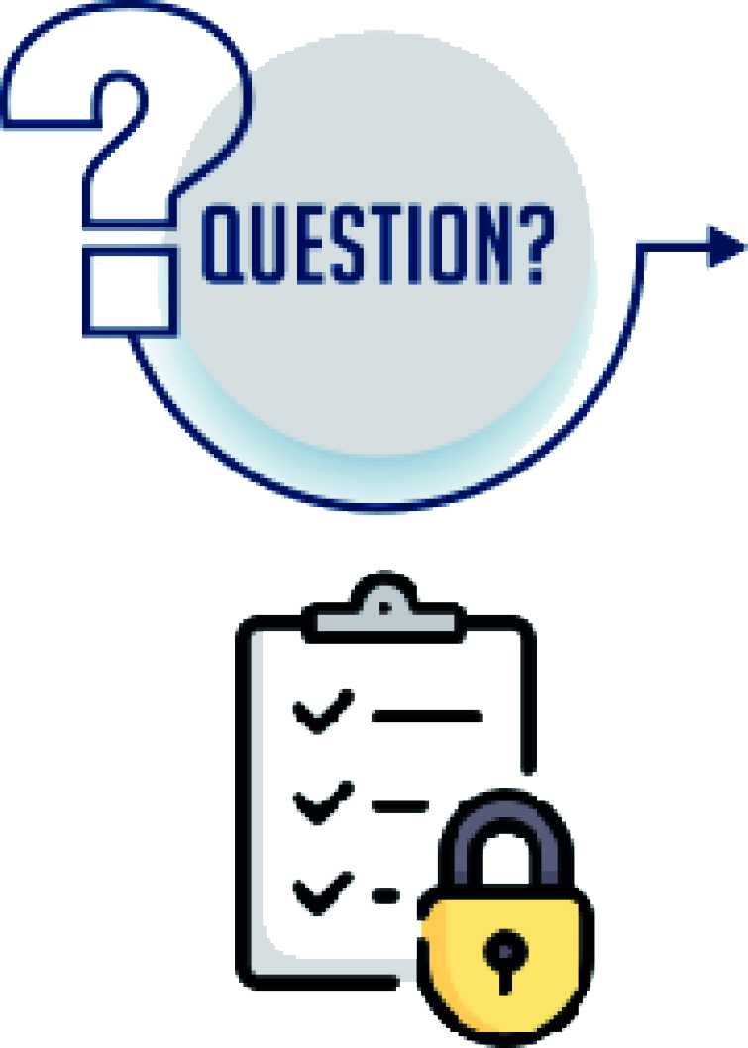 | During the study:  - If you have any questions, please ask.  - You may opt to withdraw your relative from the study at any time. This will not affect their care at any time.  - All the information we hold about your relative will be kept in the strictest confidence.

Further information and contact details

Trials Office
Nottingham Stroke Trials Unit
D floor South block, Room 2123
Queens Medical Centre
University of Nottingham
NG7 2UH

Tel: 0115 823 1782

Email: MS-TICH-3-inter@nottingham.ac.uk

