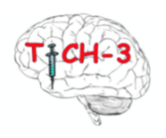

FULL CONSENT FORM FOR LEGAL REPRESENTATIVE - Professional
(Final version 1.2:16/01/2024)

Title of Study: TICH-3

EU CTR Number: 2022-500587-35-01

Name of Researcher:

Name of Participant:
Please initial box

1. I confirm that I have read and understand the information sheet final version 1.2 dated 16/01/24 for the above study and have had the opportunity to ask questions.

2. I understand that the patient’s participation is voluntary and that they are free to withdraw at any time, without giving any reason, and without their medical care or legal rights being affected. I understand that should they withdraw then the information collected so far cannot be erased and that this information may still be used in the project analysis.

3. I agree to the participant taking part in the above study.

______________________ __________________________________

Name of participant Relationship to participant

______________________ __________ ______________________

Name of professional Date Signature

________________________ ______________ ____________________
Name of researcher taking consent Date Signature
3 copies: 1 for participant, 1 for the project notes and 1 for the medical notes

