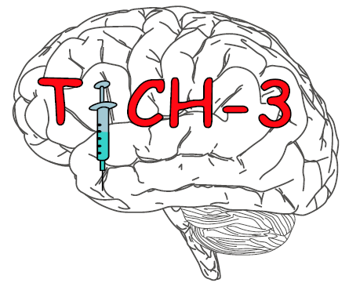

Assessment and monitoring of remote IMP storage

Study Title: | Tranexamic acid for hyperacute spontaneous IntraCerebral Haemorrhage (TICH-3)
EudraCT No: | 2021-001050-62
Chief Investigator: | Professor Nikola Sprigg
Site:
Principal Investigator:

Description of proposed area for IMP |  | Suitable for use (Yes/No) | Comments
Security measures in place (location, access controls etc)
Size and description of proposed storage area (shelves, cupboards etc)
If not for exclusive use, what controls are in place to segregate IMP from other medicines
Description of IMP management. The following should be available.
Dispensing procedure with documented training for research team | Select the next lowest numbered available treatment pack. Prescribing and administration guide to be followed.
Accountability procedure with documented training for research team | Prescribing and administration guide to be followed.
A procedure for transfer of IMP between pharmacy and proposed storage facility
Proposed methods of maintaining pharmacy oversight
Copies of accountability logs supplied to pharmacy (agree time interval and/or trigger factors)
Pharmacy to monitor facilities and IMP management (agree time interval and/or trigger factors)
Other measures

Pharmacy Approval (Clinical Trials Pharmacist) or delegated responsible person
Signature: |  | Print name:
Title: |  | Date:

Confirmation of agreed arrangements by research team
Signature: |  | Print name:
Title: |  | Date:

