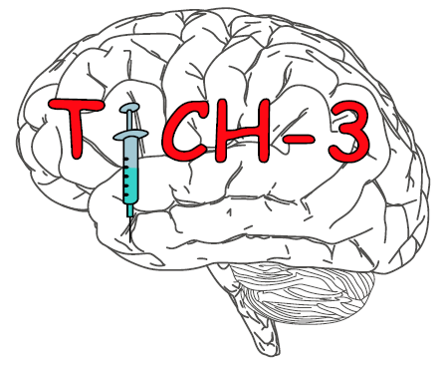

IMP Check

** CHECKS MUST BE COMPLETED AT LEAST MONTHLY **

Study Title: | Tranexamic acid for hyperacute spontaneous IntraCerebral Haemorrhage (TICH-3)
EudraCT No: | 2021-001050-62
Site:
Principal Investigator:

I confirm that I have checked that all treatment packs held in the locked cupboard matched the drug accountability log and the TICH-3 website, on the date shown below and that all are in date. NOTE: All expired IMP must be destroyed.

Any discrepancies must be recorded and investigated immediately to resolve the situation. The coordinating centre in Nottingham must also be informed immediately and kept up to date with any investigations.

DATE/TIME | SIGNATURE | COMMENTS

