**University of Nottingham**

**School of Medicine**

Queen's Medical Centre

Nottingham

NG7 2UH

Patient Information Sheet – Final Version 1.1, 2 March 2023

**Does swallow therapy with feedback in the early stages after stroke improve swallowing?**

**Research –** Swallowing – Eating and drinking



**Can you help?** Here is some information …..



**Where?** In hospital



**Who?**

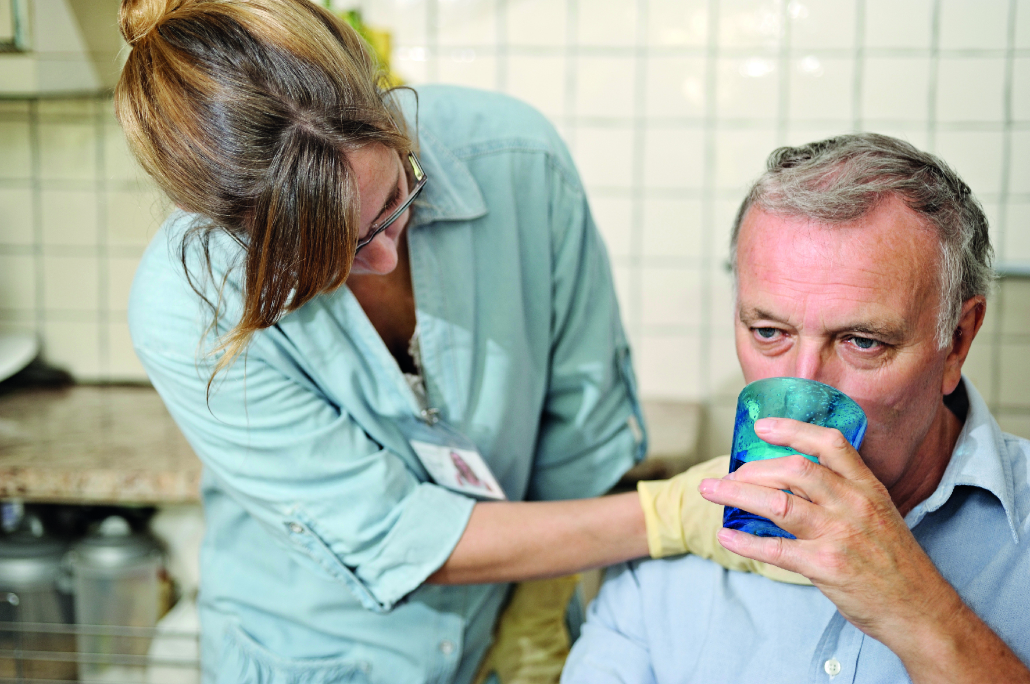**

**Speech and Language Therapists**

**How long?** 2 weeks



**Monday**

**Tuesday**

**Wednesday**

**Thursday**

**Friday**

**Phone call at home in 3 months**



**What does it involve?**

**ASSESSMENT**

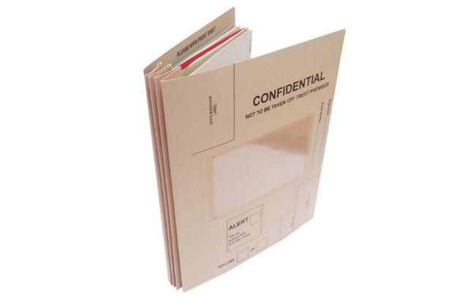Health information

Questionnaire



Bedside swallow assessment

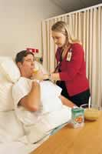

USUAL CARE – Different types

Swallow assessments and reviews



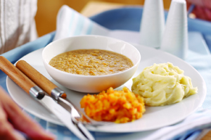Swallow trials/modified diets

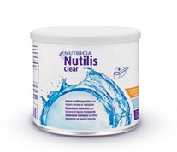

**GROUP 1**

**Therapy with feedback – once a day**

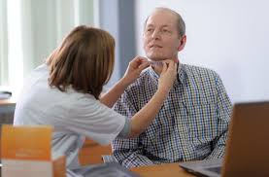

**GROUP 2**

**Therapy with feedback – twice a day**

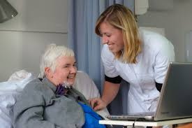

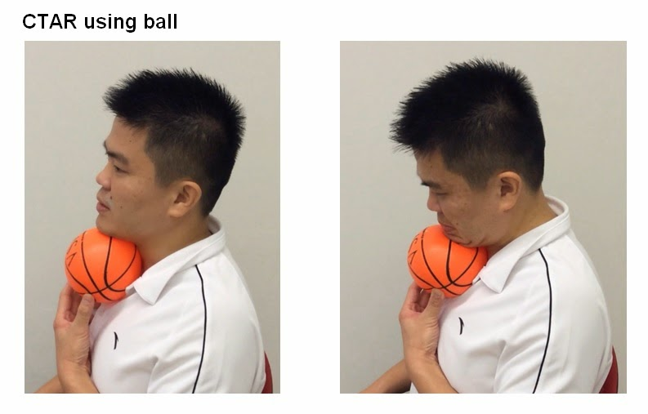**GROUP 1, 2 & 3**

**USUAL CARE EXERCISES**

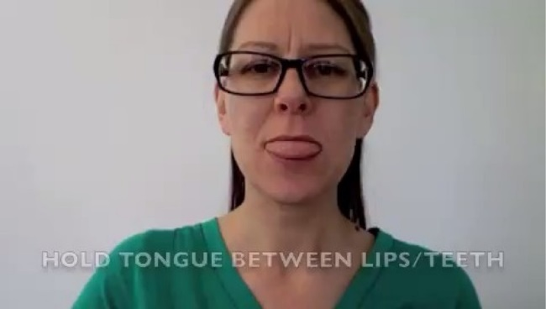

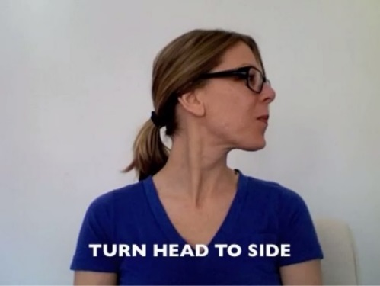

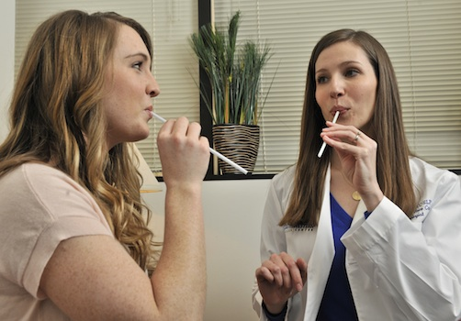



**Why have you been invited?**

You have problems swallowing …



**Which group will I be in?**

GROUP 1, GROUP 2 OR GROUP 3



**Benefits?**

**May help to improve swallowing…**



**Any Risks?**



No side effects

No safety concerns

**You can choose ….**



**You can stop at any time.**



**What if something goes wrong?**



If you are unhappy **Tell me!**

If you are still unhappy



CONTACT:

PALS, Tel [Add local PALS number]

**Will my taking part in this study be kept confidential?**



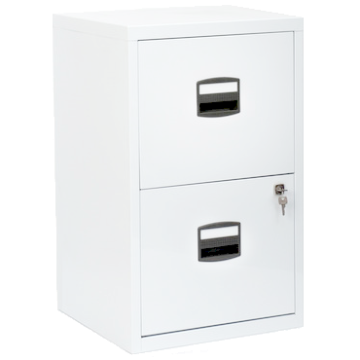

**What will happen to the results of the research study?**



Send you a summary

Publish results

Present at conferences

**Who is organising and funding the research?**



**Who has reviewed the study?**



**Bromley Research Ethics Committee**

**Contact for Further Information**

If you require any further information regarding this study please contact:

Dr Jacqui Benfield,

Speech and Language Therapist

Associate Clinical Lecturer

Tel: 01332 785891.

[jacqueline.benfield1@nottingham.ac.uk](mailto:jacqueline.benfield1@nottingham.ac.uk)

Thank you for your time