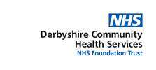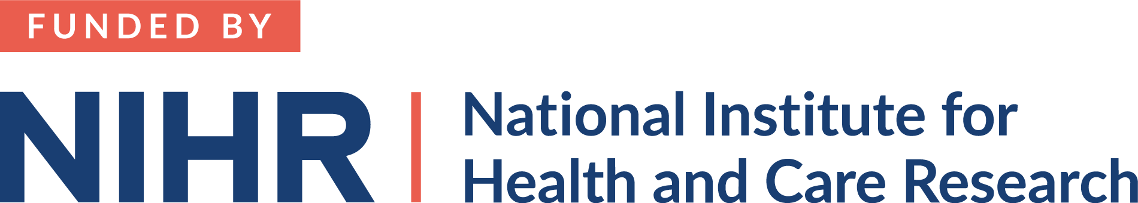****

**University of Nottingham, School of Medicine**

Queen's Medical Centre

Nottingham

NG7 2UH

**SLT/SLTA Interviews. Final Version 1.1, 2 March 2023**

**Swallow strength and skill training with biofeedback in acute post stroke dysphagia**

**Name of chief investigator: Dr Jacqueline Benfield**

**IRAS Project ID: 319969**

You have been invited to take part in a research study. Before you decide whether to take part it is important for you to understand why the research is being done and what it will involve. One of our team will go through the information sheet with you and answer any questions you have. Talk to others about the study if you wish. Ask us if there is anything that is not clear.

**What is the research?**

Previous swallow strength and skill training with sEMG biofeedback studies have reported improvements in swallowing in patients with chronic dysphagia and research is now exploring the effects with acute dysphagia. The purpose of the study is to explore which treatment dose of swallow strength and skill training (ST) results in greater improvements in dysphagia severity and if it is clinically feasible to deliver the intervention in an acute stroke NHS setting.

**Why have I been invited?**

We are inviting you because you have been trained to deliver swallow strength and skill training (ST) using surface electromyography (sEMG) biofeedback to patients as part of the clinical trial in the stroke unit where you work.

**Do I have to take part?**

It is up to you to decide whether or not to take part. If you do decide to take part you will be given this information sheet to keep and be asked to sign a consent form.

Your participation is voluntary and you are free to withdraw at any time, without giving any reason, and this will not affect your legal rights.

**What will happen to me if I take part?**

We will arrange to observe one of the ST sessions you deliver to one of the participants in the study. The purpose of this is to determine the feasibility of delivering ST to acute stroke patients, to evaluate the effectiveness of the training, to determine facilitators and barriers to successful therapy delivery and what adaptations are needed for specific patients and contexts. The researcher will make notes during the session pertaining to any barriers or facilitators that enabled the ST to be completed successfully.

**Expenses and payments**

Participants will not be paid to participate in the study but your time away from clinical practice will be reimbursed to your trust.

**What are the possible disadvantages and risks of taking part?**

The observations are to determine whether the intervention in its current form is feasible as to carry out in an acute setting, not to judge you as a therapist, but it may be that you feel uncomfortable being observed.

**What are the possible benefits of taking part?**

The insights gained from the observations of how the intervention is delivered and received may help to guide future research and clinical provision for people with dysphagia post stroke.

**What if there is a problem?**

If you have a concern about any aspect of this study, you should ask to speak to the researchers who will do their best to answer your questions. The researchers’ contact details are given at the end of this information sheet. If you remain unhappy and wish to complain formally, you can do this by contacting [please provide the contact details of PALS for the hospital]

In the event that something does go wrong and you are harmed during the research and this is due to someone's negligence then you may have grounds for a legal action for compensation against the University of Nottingham but you may have to pay your legal costs.

**Will my taking part in this study be kept confidential?**

We will follow ethical and legal practice and all information about you will be handled in confidence.

All information which is collected about you during the course of the research including the audio recording will be kept strictly confidential, stored in a secure and locked office, and on a password protected database at the University of Nottingham.

Under UK Data Protection laws the University is the Data Controller (legally responsible for the data security) and the Chief Investigator of this study (named above) is the Data Custodian (manages access to the data). This means we are responsible for looking after your information and using it properly. Your rights to access, change or move your information are limited as we need to manage your information in specific ways to comply with certain laws and for the research to be reliable and accurate. To safeguard your rights we will use the minimum personally – identifiable information possible.

The data collected for the study will be looked at and stored by authorised persons from the University of Nottingham who are organising the research. They may also be looked at by authorised people from regulatory organisations to check that the study is being carried out correctly. All will have a duty of confidentiality to you as a research participant and we will do our best to meet this duty.

Where possible information about you which leaves the [site] will have your name and address removed and a unique code will be used so that you cannot be recognised from it.

Your contact information will be kept by the University of Nottingham for 1 year after the end of the study. This information will be kept separately from the research data collected and only those who need to will have access to it. All other data (research data) will be kept securely for 7 years. After this time your data will be disposed of securely. During this time all precautions will be taken by all those involved to maintain your confidentiality, only members of the research team given permission by the data custodian will have access to your personal data.

In accordance with the University of Nottingham’s, the Government’s and our funders’ policies we may share our research data with researchers in other Universities and organisations, including those in other countries, for research in health and social care. Sharing research data is important to allow peer scrutiny, re-use (and therefore avoiding duplication of research) and to understand the bigger picture in particular areas of research. Data sharing in this way is usually anonymised (so that you could not be identified) but if we need to share identifiable information we will seek your consent for this and ensure it is secure. You will be made aware then if the data is to be shared with countries whose data protection laws differ to those of the UK and how we will protect your confidentiality.

Although what we observe and note down is confidential, should we observe anything which we feel puts you or anyone else at any risk, we may feel it necessary to report this to the appropriate persons.

You can find out more about how we use your information and to read our privacy notice at:

https://www.nottingham.ac.uk/utilities/privacy.aspx.

**What will happen if I don’t want to carry on with the study?**

Your participation is voluntary and you are free to withdraw at any time, without giving any reason, and without your legal rights being affected. If you withdraw we will no longer collect any information about you or from you but we will keep the information about you that we have already obtained as we are not allowed to tamper with study records and this information may have already been used in some analyses and may still be used in the final study analyses. To safeguard your rights, we will use the minimum personally-identifiable information possible.

**What will happen to the results of the research study?**

It is likely that the research will be written up for submission to a journal. There will be no identifying information about any participants in any publications. The results will be shared with other stroke professionals with the hope that it will contribute to the wider understanding about therapy for people with swallowing difficulties after stroke.

**Who is organising and funding the research?**

The research is being funded by the National Institute of Health Research (NIHR) Clinical Lectureship NIHR 302177.

The research is sponsored by the University of Nottingham.

**Who has reviewed the study?**

This study has been reviewed and approved by XXXX Research Ethics Committee.

**Contact for Further Information**

If you require any further information regarding this study please contact:

* Dr Jacqui Benfield, Highly Specialist Speech and Language Therapist/Associate Clinical Lecturer

Tel: 01332 785891. Email: [jacqueline.benfield1@nottingham.ac.uk](mailto:jacqueline.benfield1@nottingham.ac.uk)

Thank you for taking part in the study.