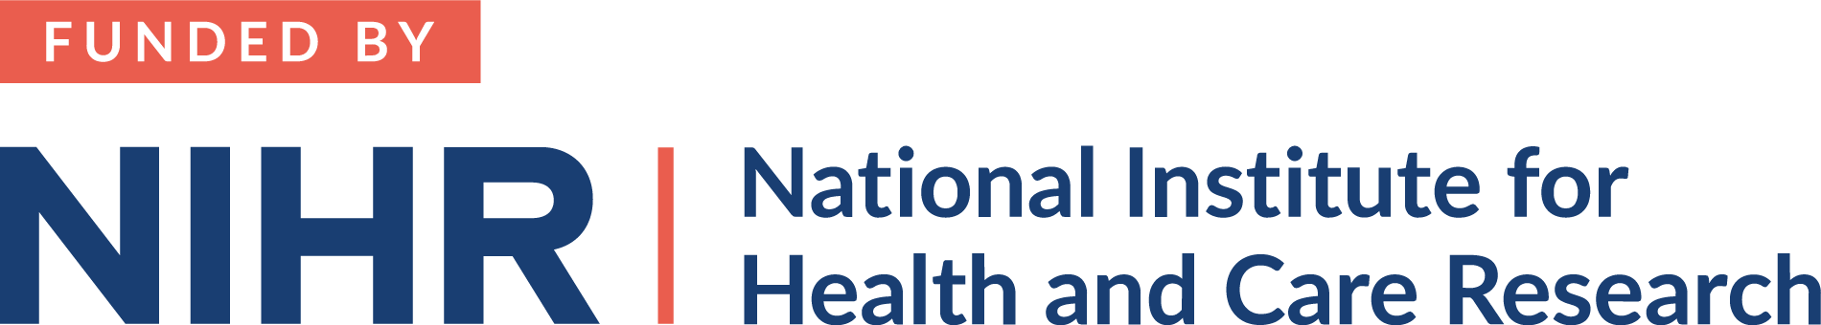****

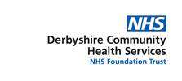

**University of Nottingham, School of Medicine**

Queen's Medical Centre

Nottingham

NG7 2UH

Participant Information Sheet (including Videofluoroscopy information)

Final Version 1.1

28 February 2023

**Does swallow therapy with feedback in the early stages after stroke improve swallowing?**

We are doing a research study on the swallowing difficulties that patients may experience after a stroke. We would therefore like to invite you to take part. Before you decide whether to take part it is important for you to understand why the research is being done and what it will involve. Please take time to read the following information carefully and discuss it with friends and relatives if you wish to. Ask us if there is anything that is not clear or if you would like more information. Take time to decide whether you wish to take part or not. If you decide to take part you may keep this leaflet. Thank you for reading this.

**What is the research?**

Swallowing therapy has shown to help patients improve their swallowing after a stroke. We would like to find out whether swallowing therapy with visual feedback helps improve patient’s swallowing more than usual therapy and whether having this therapy twice daily is more effective than once a day. We would also like to know whether swallow therapy with feedback can feasibly be delivered by hospital teams in the early stages after stroke. Please note that this research will not delay your discharge from hospital.

**Why have you been invited?**

You have been invited because you have difficulties swallowing as a result of a new stroke. We are looking for 120 people in total.

**Do you have to take part?**

It is up to you to decide whether or not to take part. If you do decide to take part you will be given this information sheet to keep and be asked to sign a consent form. If you decide to take part you are still free to withdraw at any time and without giving a reason. This would not affect your legal rights. If you choose not to take part it will not affect your standard care.

**What does it involve?**

Assessment

The first stage will be assessing your swallowing and health. This will involve:

* A swallowing assessment to see whether and how well you can complete the swallowing exercises. This will take about 15 minutes. If you are unable to complete the exercises you will not be asked to participate in any further assessment or therapy for this study.
* If you can complete the exercises, one of the researchers will assess your stroke severity and quality of life at bedside – this will take about 15 minutes
* The researchers will gather information from your medical notes about your swallowing and health since your stroke
* You will also be offered an assessment of your swallowing using video x-ray (known as a ‘videofluoroscopy’) in the X-ray department. A porter will collect you from the ward and take you to x-ray. You may be away from the ward for approximately 50 minutes but you will only be in the x-ray room for approximately 20 minutes. This assessment is **optional**.

Usual care during the research period

* As long as you need it you will be under the care of a speech and language therapist
* Your swallowing will be assessed and reviewed as usual
* The speech and language therapist will make recommendations about what is safe for you to eat and drink

Therapy

To check what dose of this specific therapy is beneficial, we need to compare it to the care that people with swallowing difficulties usually get. You will be randomly assigned to one of three groups. The groups are selected by a computer which has no information about the individual – i.e. by chance. The groups will be as follows:

1. 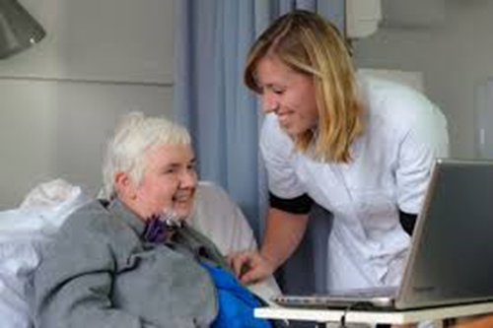Standard dose feedback group – During approximately 35 minute therapy sessions the researcher will secure a cushioned pad underneath your chin to measure your swallowing muscles. People who have hair underneath their chin will need to have this shaved by nursing staff on the ward beforehand. You will be able to see a line on the computer screen which will move when you swallow. You will be taught how to use this information from the screen to alter the strength and timing of your swallow. The exercises are designed to be challenging as this is important for rehabilitation but they will be tailored to each individual to make them achievable. You may also do other swallowing exercises with your usual speech and language therapist or be asked to carry out exercises on your own. Over 2 weeks you will receive 10 sessions offered 5 days a week.
2. High dose feedback group – the therapy will be the same as above but over 2 weeks you will receive 20 sessions. This will mean having two therapy sessions a day.
3. Usual therapy group – Over 2 weeks your usual speech and language therapist will continue to review your swallowing, make recommendations about your eating and drinking and if appropriate they may practice swallowing exercises with you. You may also be asked to carry out some exercises on your own.

Re-assessment

After the therapy we will need to repeat the following assessments:

* A swallowing assessment at bedside – this will take about 15 minutes
* One of the researchers will assess your stroke severity and quality of life at bedside – this will take about 15 minutes
* The researchers will also gather information from your medical notes about your swallowing and health since your stroke
* Videofluoroscopy – an assessment of your swallowing using video x-ray in the X-ray department if you had one at the beginning
* At the point of discharge, you will receive a diary to complete about your swallowing and your health. You do not need to send this back but we will ask you about when we call you at 3 months.

At 3 months

We will telephone you at home or wherever you are residing to collect the following information, which should take about 15 - 30 minutes:

* The researchers will ask you about your health and your swallowing and quality of life since your stroke

Here is a timeline of events:

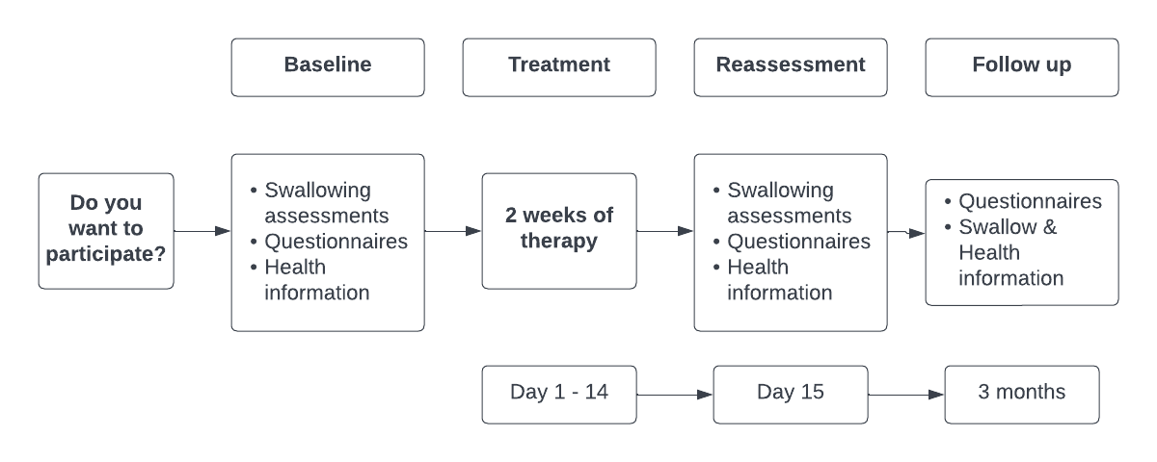

**What happens after the therapy period?**

If you continue to have swallowing difficulties after the 2 week therapy period you will remain under the care of the speech and language therapy team for as long as they feel is beneficial.

**Where will the research take place?**

We will come to you to carry out most of the assessments and therapy – whether that is on this ward or another ward. For the videofluoroscopy you will be taken to x-ray. If you have been discharged home before the two weeks of therapy are finished, we will aim to contact you at 2 weeks to complete the re-assessments that can be carried out over the phone.

**What are the possible benefits of taking part?**

We cannot promise the study will help you but the information we get from this study may help us to improve the rehabilitation we offer in the future.

**What are the possible disadvantages and risks of taking part?**

There have not been any side effects or safety concerns associated with this therapy in previous research. If you are assigned to one of the intervention groups this will take up some of your time.

If you take part in this study you will have two Videofluoroscopy assessments, or video x-rays. One or both of these may be extra to those that you would have if you did not take part. These procedures use ionising radiation to form images of your swallowing and provide your speech therapist with other clinical information. Ionising radiation may cause cancer many years or decades after the exposure. We are all at risk of developing cancer during our lifetime. 50% of the population is likely to develop one of the many forms of cancer at some stage during our lifetime. Taking part in this study will add only a very small chance of this happening to you. You can opt out of this.

**What will happen if I don’t want to carry on with the study?**

Your participation is voluntary and you are free to withdraw at any time, without giving any reason, and without your legal rights being affected. If you withdraw then the information collected so far will not be erased and this information may still be used in the project analysis.

If you are no longer able to participate in the therapy we may still want to continue with the assessments and follow up. Your next of kin or a member of your family will be asked their opinion as to whether this is something that you would want.

**Expenses and payments**

Participants will not be paid to participate in the study.

**Involvement of the medical team/GP?**

If you agree to participate in this study a copy of your signed consent form will be filed in your medical records therefore your hospital medical team will be aware that you have agreed to participate in this study.

**What if something goes wrong?**

In case you have a complaint on your treatment by a member of staff or anything to do with the study, you can initially approach the lead investigator. If this achieves no satisfactory outcome, you should then contact the PALS Department, Tel [Add local PALS number].

**Will my taking part in this study be kept confidential?**

We will follow ethical and legal practice and all information about you will be handled in confidence.

If you join the study, some parts of your medical records and the data collected for the study will be looked at by authorised persons from the University of Nottingham who are organising the research. They may also be looked at by authorised people to check that the study is being carried out correctly. All will have a duty of confidentiality to you as a research participant and we will do our best to meet this duty.

Under UK Data Protection laws the University is the Data Controller (legally responsible for the data security) and the Chief Investigator of this study (Dr Jacqueline Benfield) is the Data Custodian (manages access to the data). This means we are responsible for looking after your information and using it properly. Your rights to access, change or move your information are limited as we need to manage your information in specific ways to comply with certain laws and for the research to be reliable and accurate. To safeguard your rights we will use the minimum personally – identifiable information possible.

You can find out more about how we use your information and to read our privacy notice at:

https://www.nottingham.ac.uk/utilities/privacy.aspx.

All information which is collected about you during the course of the research will be kept **strictly confidential**, stored in a secure and locked office, and on a password protected database. Where possible, any information about you which leaves the hospital will have your name and address removed (anonymised) and a unique code will be used so that you cannot be recognised from it. However, sometimes we need to ensure that we can recognise you to link the research data with your medical records so in these instances we will need to know your name and date of birth. We will also need this information if we need to follow up your medical records as part of the research, where we may need to ask the Government services that hold medical information about you (such as NHS Digital, the Office for National Statistics, among others) to provide this information to us. We also ask your permission to check with the NHS Information Centre to check on your condition 3 months, after your stroke and to confirm your contact details. By signing the consent form you agree to the above.

This information will include your:

* Name
* Date of birth
* NHS number
* Address
* Telephone number

Your personal data will be kept for 1 year after the end of the study so that we are able to contact you about the findings of the study *and* possible follow-up studies. All other data (research data) will be kept securely for 7 years. After this time your data will be disposed of securely. During this time all precautions will be taken by all those involved to maintain your confidentiality, only members of the research team will have access to your personal data.

In accordance with the University of Nottingham’s, the Government’s and our funders’ policies we may share our research data with researchers in other Universities and organisations, including those in other countries, for research in health and social care. Sharing research data is important to allow peer scrutiny, re-use (and therefore avoiding duplication of research) and to understand the bigger picture in particular areas of research. Data sharing in this way is usually anonymised (so that you could not be identified) but if we need to share identifiable information we will seek your consent for this and ensure it is secure. You will be made aware then if the data is to be shared with countries whose data protection laws differ to those of the UK and how we will protect your confidentiality.

**What will happen to the results of the research study?**

It is likely that the research will be written up for submission to a journal. There will be no identifying information about any participants in any publications. The results will be shared with other stroke professionals with the hope that it will contribute to the wider understanding about therapy for people with swallowing difficulties after stroke.

**Who is organising and funding the research?**

The research is being funded by the National Institute of Health Research (NIHR) Clinical Lectureship NIHR 302177.

The research is sponsored by the University of Nottingham.

**Who has reviewed the study?**

This study has been reviewed and approved by XXXX Research Ethics Committee.

**Contact for Further Information**

If you require any further information regarding this study please contact:

* Dr Jacqui Benfield, Highly Specialist Speech and Language Therapist/Associate Clinical Lecturer

Tel: 01332 785891. Email: [jacqueline.benfield1@nottingham.ac.uk](mailto:jacqueline.benfield1@nottingham.ac.uk)

Or ask the nurses on the ward to contact the researcher Jacqui Benfield on your behalf

Thank you for your time.