**DSRS Crib sheet**

When completing the CRF for **Measured Outcome**, you will be asked in **Section B** what the DSRS score is:

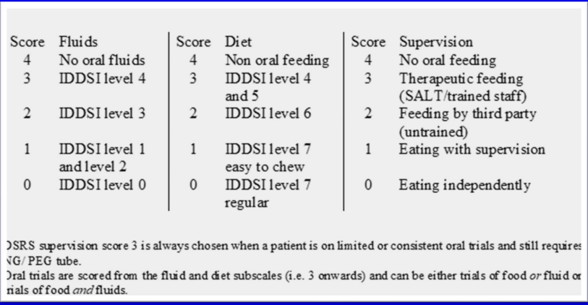

**Minimal amount Oral trials** (less than 15 tsp/day)

* Fluid and food items should be scored as 4, with a supervision score of 3 to indicate trials are taking place (DSRS supervision score 3 is always chosen when a patient is on limited or consistent oral trials and still requires NG/PEG tube).
* e.g. If a pt was having ‘5 teaspoons of level 3 moderately thick fluids 3 times daily’ or ‘3 teaspoons of level 4 puree yoghurt only 3 times daily’, you would score this as DSRS 11 (4,4,3)
* In the example below, the participant would be scored on DSRS as Fluids = 4, Diet = 4 (because they are on less than 15 tsp/day) and Supervision = 3 (because they are on limited oral trials and still on a NGT)

|  |  |
| --- | --- |
| SALT, WARD 4, SRU, FNCH  Pt seen asleep in bed. NGT & mitts insitu. Pt very drowsy, took some time to wake. Seen in best interests - compliant with swallowing ax.  OROMOTOR - still struggling to follow any commands, even with model ? oral apraxia  SWALLOWING AX: trialled 0.5 & full tsps L0 = poor oral control on 1st 0.5 spoonful but pt was still q. sleepy. Strong coughing observed, face reddening, indicating away penetration. Trialled 0.5 tsps again, better oral control, but again coughed once got to full tsps.  - L4 (tsps) = trialled strawberry yogurt. 4 x tsps given. Better oral control, pt making attempts to clear R cheek when encouraged by SLTist, second swallow observed, throat cleared after 4th tsp so discontinued.  D/W Dr Greenhall after - happy for pt to start on oral trials as chest clear.  IMPRESSION: some improvement in managing very small amounts of diet trials, better at clearing R cheek. Suggest cautiously commencing on oral trials.  RECOMMEND:  *** ORAL TRIALS ONLY***  - Up to 3 tsps L4 pureed diet TDS  - Full assistance - watch for 2nd swallow  - Prompt pt to check he has cleared his R cheek  - Stop if any concerns and inform SLT  - Continue NGT feeding  SIS updated and put above bed. Updated nursing handover and hostess sheet.  Plan: Check managing oral trials. Practise Y/N reliability and written word and picture comprehension. Attend welcome meeting. Attempt goal setting if able. | |
| Patient Contact: 15 minutes |  |

* Please note – Level 4 pureed diet SHOULD NOT be confused with Level 4 Extremely thick fluids (it is very unlikely a speech therapist would ever recommend Level 4 Extremely thick fluids. They are considered separate on the DSRS, it just happens that they are of the same consistency, hence why they are both classed as Level 4 on IDDSI descriptors. However, most patients would be unlikely to want to try Level 4 Extremely thick fluids because it is too thick to drink, whereas some foods are naturally of Level 4 pureed consistency, such as yogurt).

**Consistent amount Oral trials** (more than 15tsp/day)

* Score as per consistency on diet/fluids sections but **always score supervision = 3**
* e.g. ½ portions of level 4 puree diet 3 x daily, up to 100mls of level 2 mildly thick fluids 3 times daily = DSRS 7 (1, 3, 3)
* OR ‘Up to 10 tspns of level 4 puree diet 3 x day (no fluids)’ = DSRS 10 (4, 3, 3)
* OR ‘Up to 5 sips of level 1 slightly thick fluids 6 x day (no diet)’ = DSRS 8 (1, 4, 3)
* In the example below, although 'oral trials' hasn't been explicitly written in the notes, this is implied because the patient is still only having half portion meals and has a NGT insitu. They would score on the DSRS as Fluids = 4, Food = 3, Supervision = 3 (because they are still classed as 'consistent oral trials' given they aren't on unlimited amounts of food and fluids and they are still reliant on NGT feeding).

|  |  |
| --- | --- |
| SPEECH AND LANGUAGE THERAPY, WARD 4, FNCH  S: Pt seen for lunch time assessment- trialled level 4 meal. NGT insitu.  O: Pt seen in bay at bedside, verbal consent gained for session. Pt managed well with half portion of meal. Slight wet vocal changes when pt spoke whilst eating. Needing clearing swallows occasionally. No definite signs of airway penetration.  A: Improving oropharyngeal dysphagia- pt started to fatigue/ had enough after eating half portion, therefore,  RECOMMEND:  **Half portion of level 4 puree diet- half of main meal and pudding. Full portion for breakfast.  **Slow pace  **No talking whilst eating  **Wait till pt has had a second swallow  **Stop if coughing/ wet vocal changes  **Regular mouthcare  H/o to hostess, placed SIS behind pts bed and updated extramed  P: Continue to review swallow. Trail fluids. | |
| Patient Contact: 25 minutes |  |