**STUDY IMAGING TRANSFER GUIDELINES**

**Web-Upload User Guide**

WI NUMBER: WI - 001

VERSION NUMBER: Version 1.0

EFFECTIVE DATE: 26/09/2018

RELEASE DATE: 03/10/2018

|  |  |
| --- | --- |
| **Signature** | **Date** |
| AUTHOR: Eleni Sakka, Imaging Data Research Manager (R4VAD) | 26/09/2018 |
| APPROVED BY: Rosalind Brown, Study Manager (R4VaD)  SIGNATURE: | 02/10/18 |
| REVIEWED BY: Eleni Sakka | 03/10/2018 |

**Contents**

**1. Introduction…………………………………………………………....................2**

**2. Preparing the images…………………………………………………………….2**

**3. Activating the R4VAD Investigator’s account………………………………..2**

**4. Logging in the R4VAD eCRF……..……………………………....……...……...3**

**5. Adding scan episode details & uploading scans…………………......…….5**

**6. Help and Queries………………………………………………………….……..11**

1. **Introduction**

The following is a step-by-step guide to completing the R4VaD Imaging Transfer Form, and sending image files by Web-Upload. Please take the time to read through this guide before you begin.

1. **Preparing the images**

**2.1 Anonymisation and labelling:**

All imaging sent to the R4VaD Imaging Office **must be anonymised and correctly labelled.** (See Imaging Transfer Guidelines, section 2)

Please also ensure that the date and time shown on the images are **the date and time the images were acquired** - **not** when they were **copied from the scanner to a portable device or disk**.

**2.2 Zip**

Study folders **must** be **zipped** (compressed) prior to transfer by web upload. For help with this, please contact your local IT department, or email [r4vad_imaging@mlist.is.ed.ac.uk](mailto:r4vad_imaging@mlist.is.ed.ac.uk)

**2.3 Portable devices**

It may be necessary to copy files to a portable device i.e. CD or memory stick, in order to transfer them to a computer connected to the internet. Files can then be uploaded directly from the portable device - no need to copy them onto the computer hard-drive first.

Please ensure the files are anonymised and zipped **before** they are copied to the portable device.

1. **Activating the R4VaD Investigator’s account**

To begin with, prior to start using your R4VaD investigator account, you will need to go through the short activation process.

**3.1** You will have received an activation email with:

* Your username
* Your Pin Number

Click on “Activate Account” which is included in the email.

**3.2** You will be led to the R4VaD eCRF portal (please note that the included screen shots from the demo portal below are the same for the live R4VAD eCRF portal).

**3.2.1** Enter your details: Investigator ID, the supplied pin number and password

Select “Activate Account”.

Your account will now be ready to use for the first time and then whenever new patients are added. Please make sure you keep your details (Username, password, and pin number) somewhere where it is safe and easy to access for future use.

1. **Logging in the R4VaD eCRF**

**4.1** Before you begin you will need:

* Your personal details for the R4VaD eCRF portal (if you don’t have these, please contact the R4VaD office: r4vad@ed.ac.uk)
* A computer connected to the internet, and a printer (if required).
* Your R4VaD centre number, and R4VaD patient number (for test imaging please refer to the instructions included at the general Imaging Transfer Guidelines. The screen shots here also apply for test imaging).
* The acquisition date and time for each study – On Diagnostic, Additional, , Recurrent stroke (post-randomisation).

**4.2** Login to the R4VaD eCRF

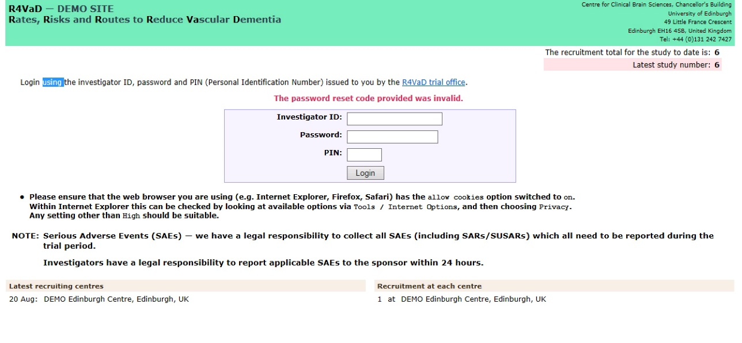

**4.2.1** Select “Continue to participant list”

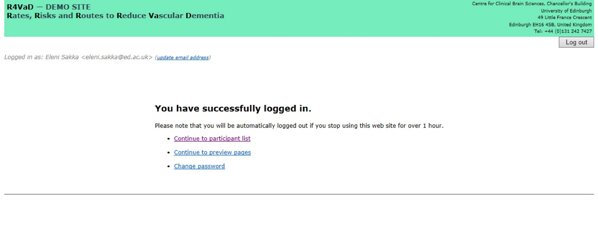

**4.2.2** The Participants list should contain the patients randomised in your centre. Instructions of adding new randomised patients should be included in separate guidelines document. Select the patient you are about to upload their scans.

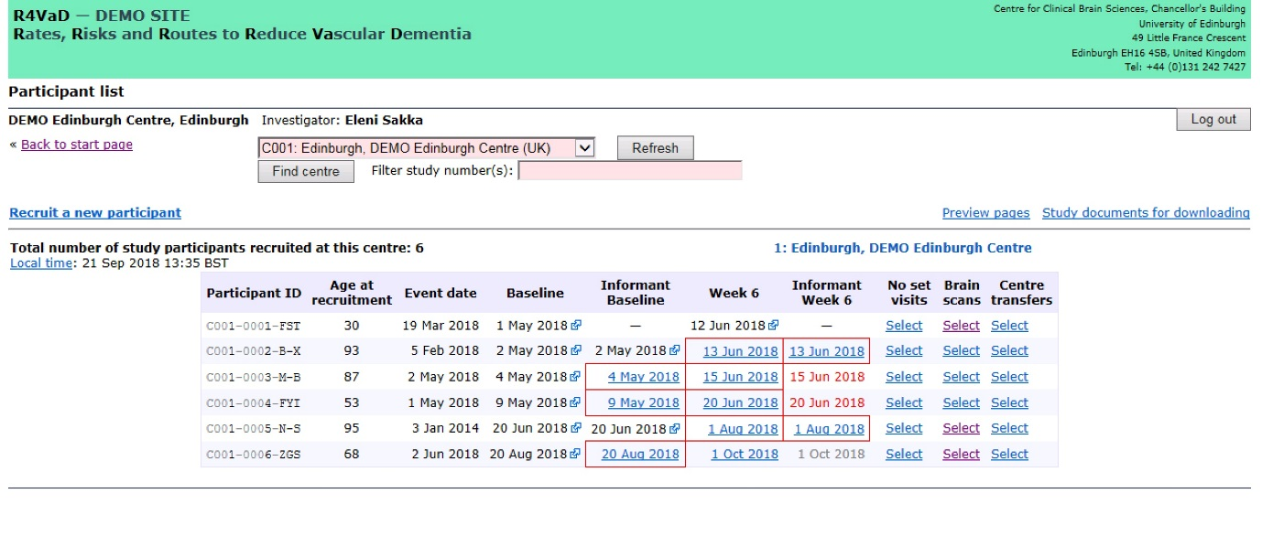

If you are about to upload a **test scan**, use the Demo eCRF, and click on Select at the Brain Scans column. This message will also pop-up:

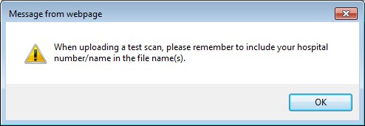

It is a reminder to add the centre number or name in the test scan file name, for the imaging manager to know where the test scan is coming from. Click on OK to continue.

Next screen comes up with the option to upload new brain scan files

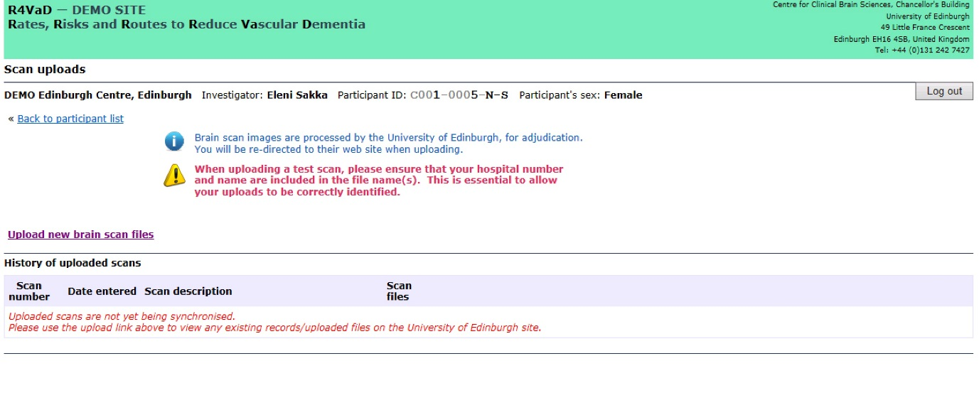

1. **Adding scan episode details & uploading scans**

**5.1** Preparing files for transfer

Prior to any uploading of R4VaD scans you will need to ensure that the scans:

**a.** **Are Anonymised** – (Read Section 2.1 of the main Image Transfer Guidelines for R4VAD)

**b.** **Have the correct date and time on images** – (Read Section 2.2 of the main Image Transfer Guidelines for R4VaD)

**c.** **Are correctly labelled for the trial** – (Read Section 2.3 of the main Image Transfer Guidelines for R4VaD)

**d.** **Are zipped** – (Read Section 2.2 of this document).

**5.2.** When the above have been checked,select “Upload new brain scan files”

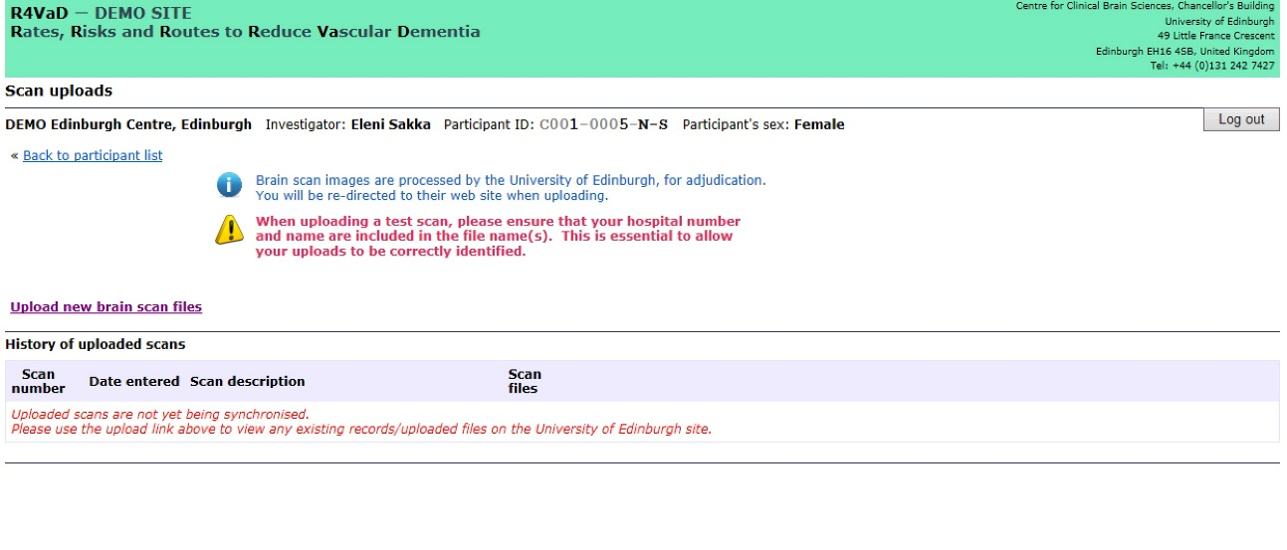

**5.2.1** Enter the patient’s details to complete the identity check. Select “Confirm identity”. The details are shown in grey fonts at the bottom. When uploading a test scan, click on **Test form** and the patient details will fill the boxes automatically.

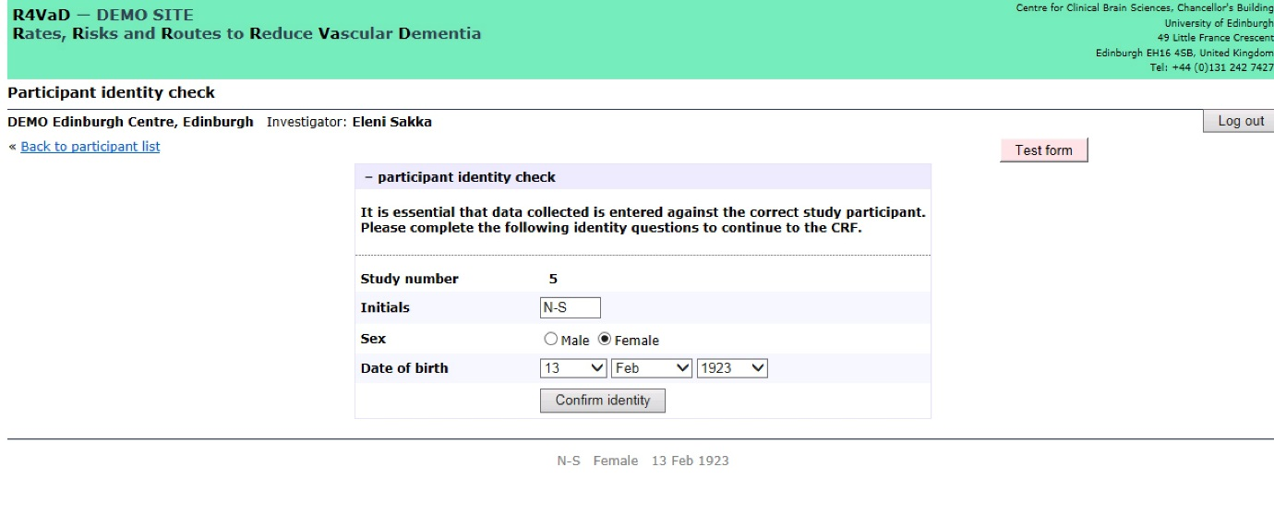

**5.2.2** Select “Add new” in the New Study column.

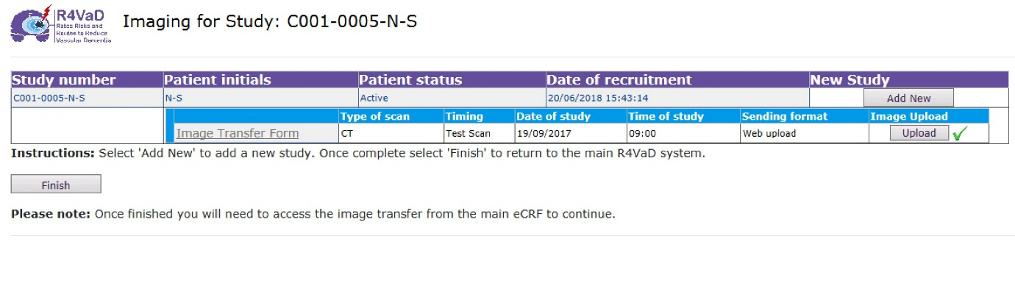

**Please remember you will need to repeat this exact procedure for every separate scan episode each patient has.**

**5.2.3** Complete the form by ticking the appropriate fields and ensuring that the date/time entered is when the imaging was acquired (see section 2.1). Please remember to select Web upload on the “Sending Format” (see red arrow). Select “Continue”.

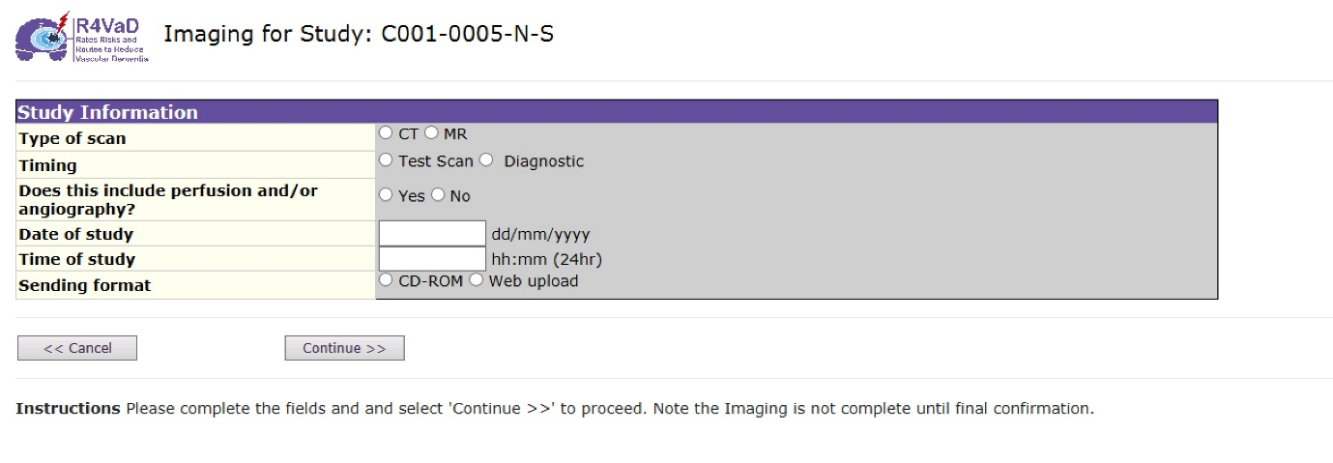

|  |
| --- |
| **Note on Timing:** this refers to when the imaging was acquired. If you are unsure, please add a comment on the following screen to notify the imaging manager who will handle the scans during the Housekeeping process. |

**5.2.4** Fill in your details and any comment you may have regarding the images you upload. Please complete all fields. It is vital that we are able to contact the person who has sent the images, in case there is a problem. Select “Continue”

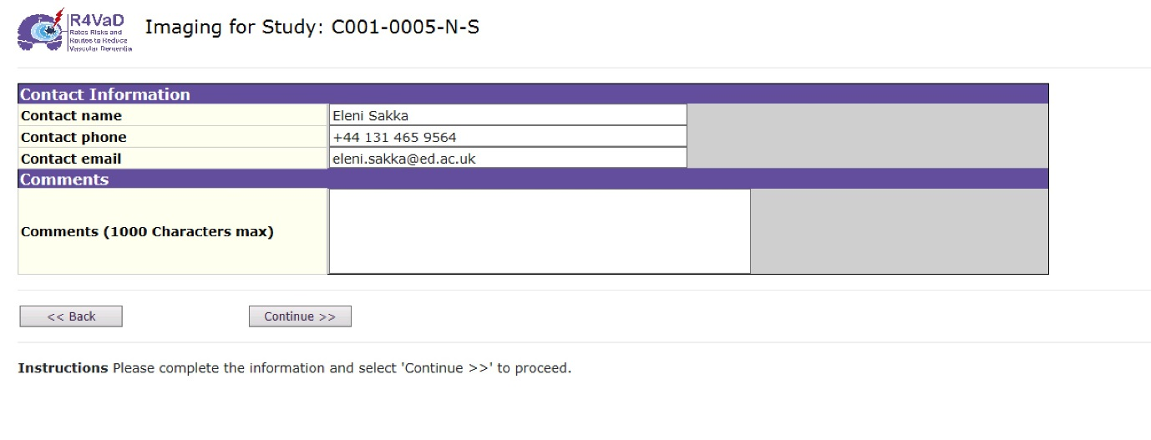

**5.2.5** An imaging summary appears. Check the details and if something is wrong, select “Back” to get to the previous screens. If everything is ok, select “Confirm”.

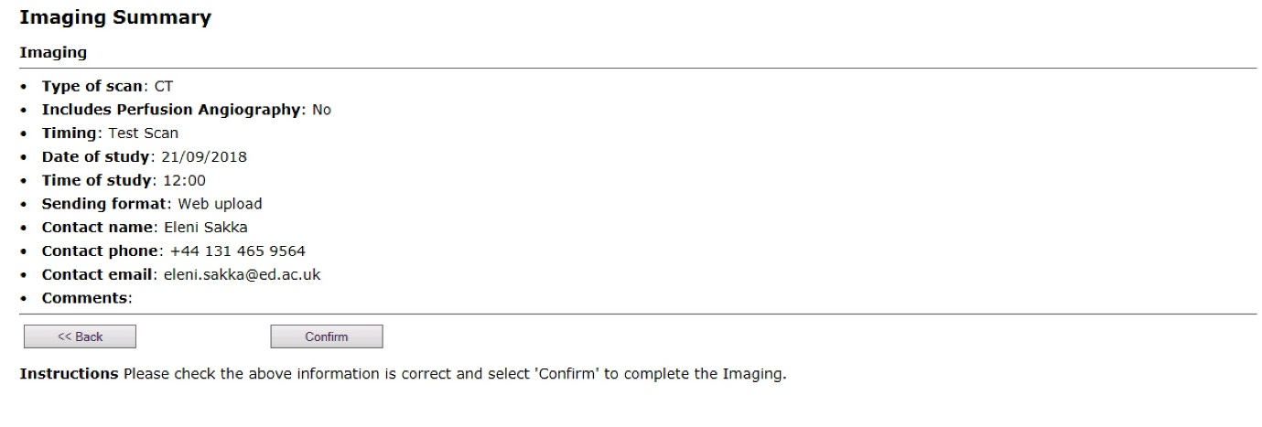

Once the details of the Scan Study are confirmed, the Imaging Manager receives an automated email notification with the Scan details. **This email constitutes the Scan Transfer Form for the Web Uploaded Scans. A Scan Transfer Form must accompany all scans sent, either by Web Upload or on CD.**

**5.2.6** The screen that follows is the Scan Transfer Form. Select “**Finish**” to continue the procedure, and/or Print to keep a copy for your records.

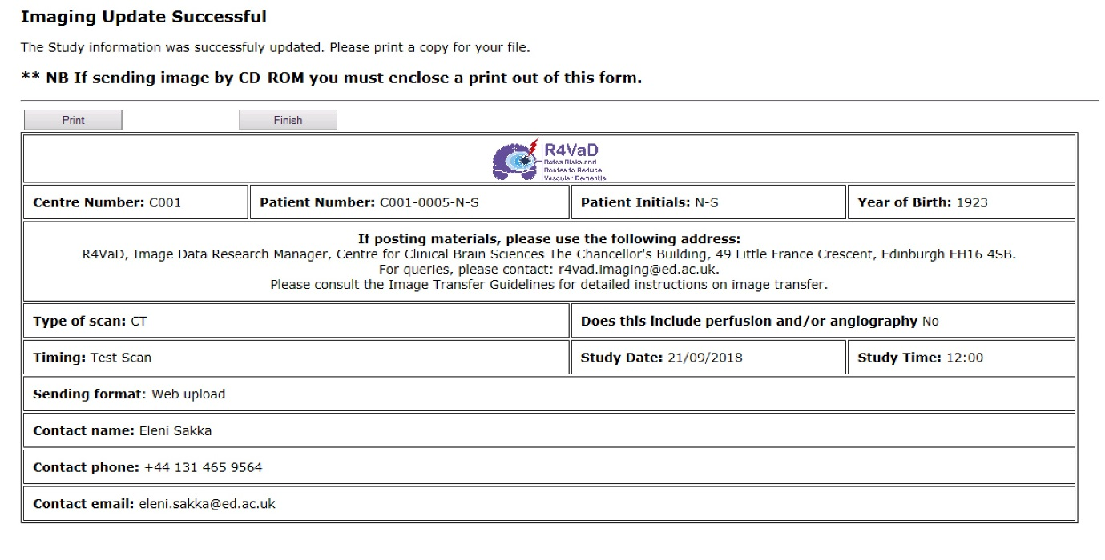

**5.2.7** The Scan study details are now recorded. You can either, stop by clicking on **Finish** (and continue the next day with the uploading) or you can click on **Upload** to continue with uploading the scans for the specific scan study (episode).

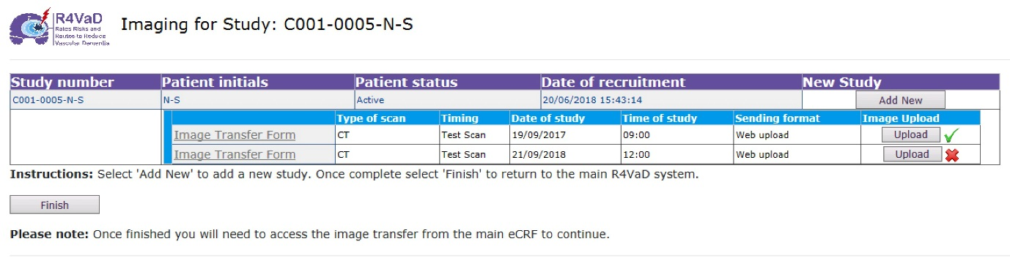

**5.2.8** When selecting Upload, on the next screen, select “Browse” to look for the designated folder where you have placed the zipped R4VaD scan folder that you wish to upload.

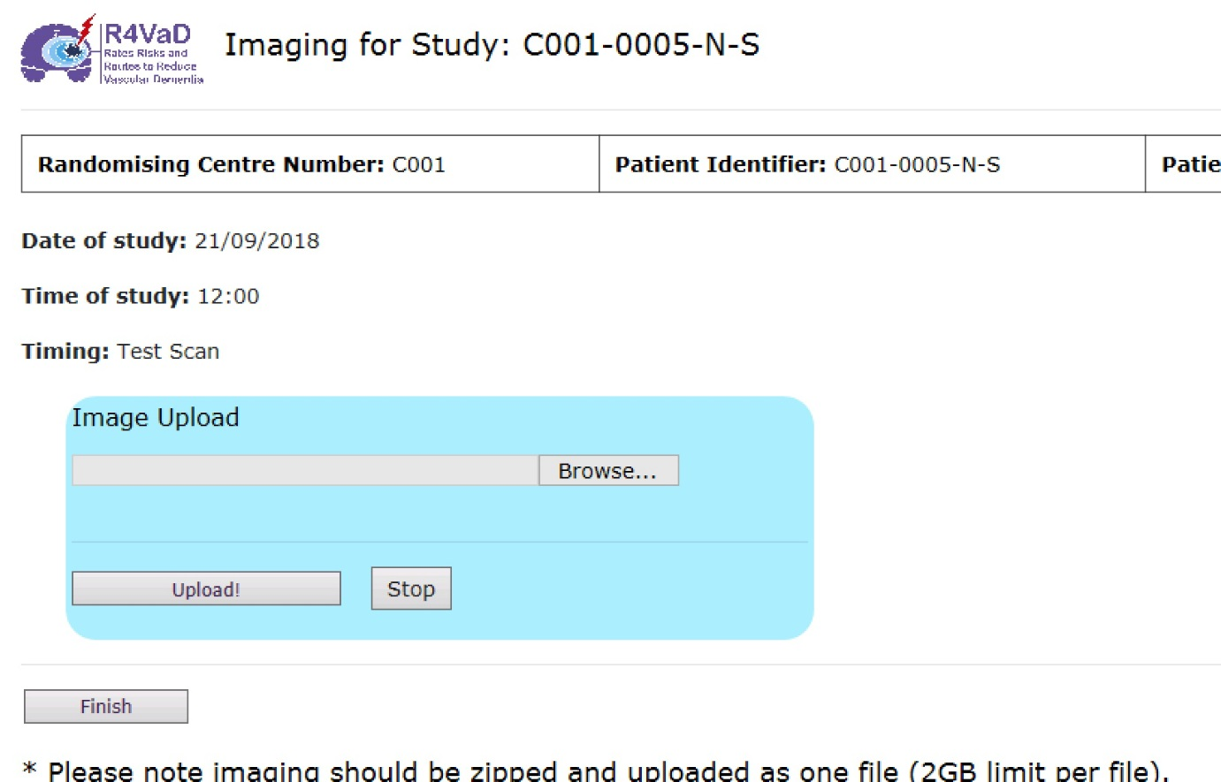

Select the zipped R4VaD folder you want and click “Open”.

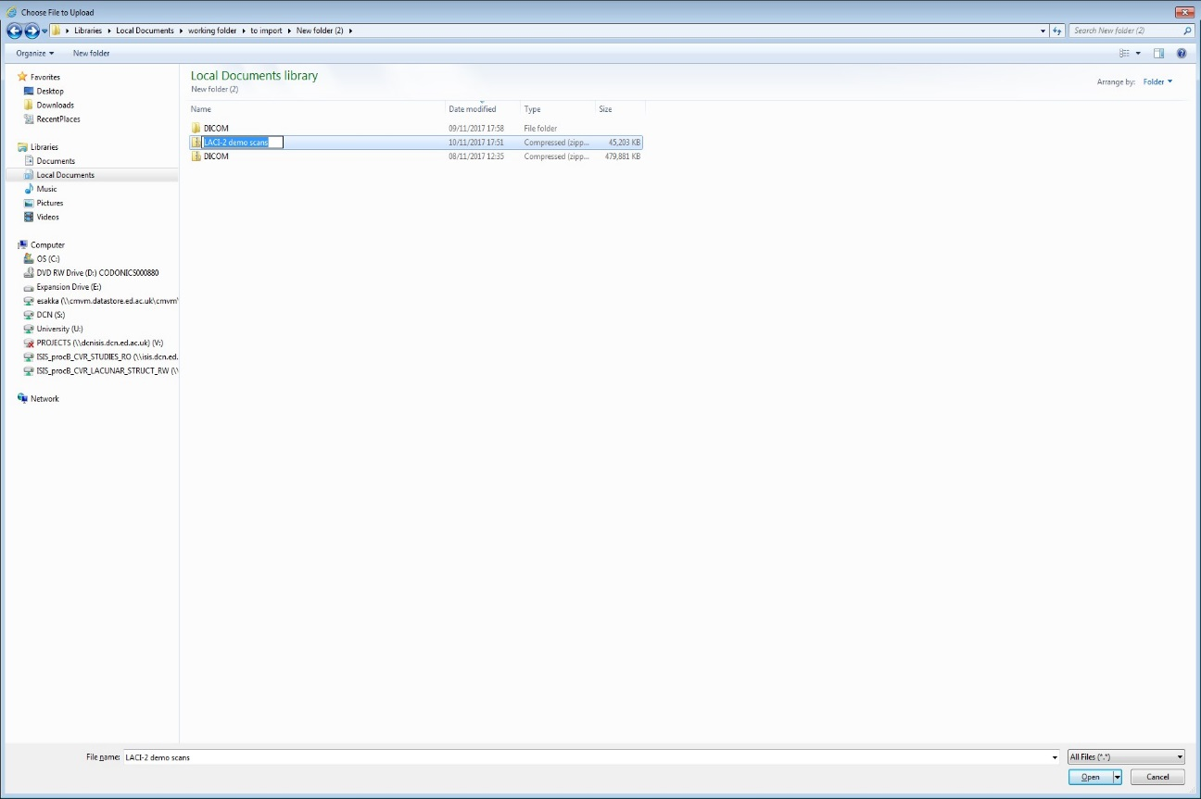

**5.2.9** The chosen zipped scan folder location is shown next to Browse. Select “Upload”

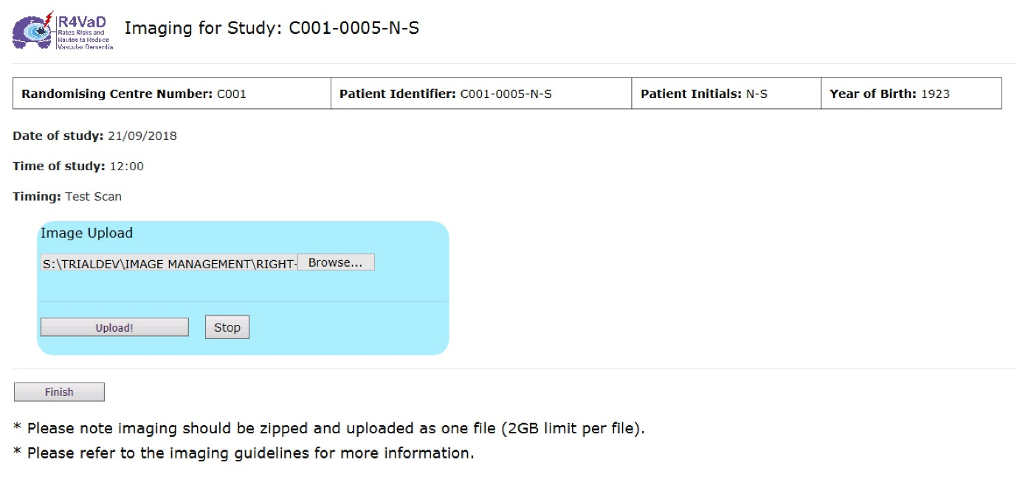

**5.2.10** When the uploading has been successful, a message is shown.

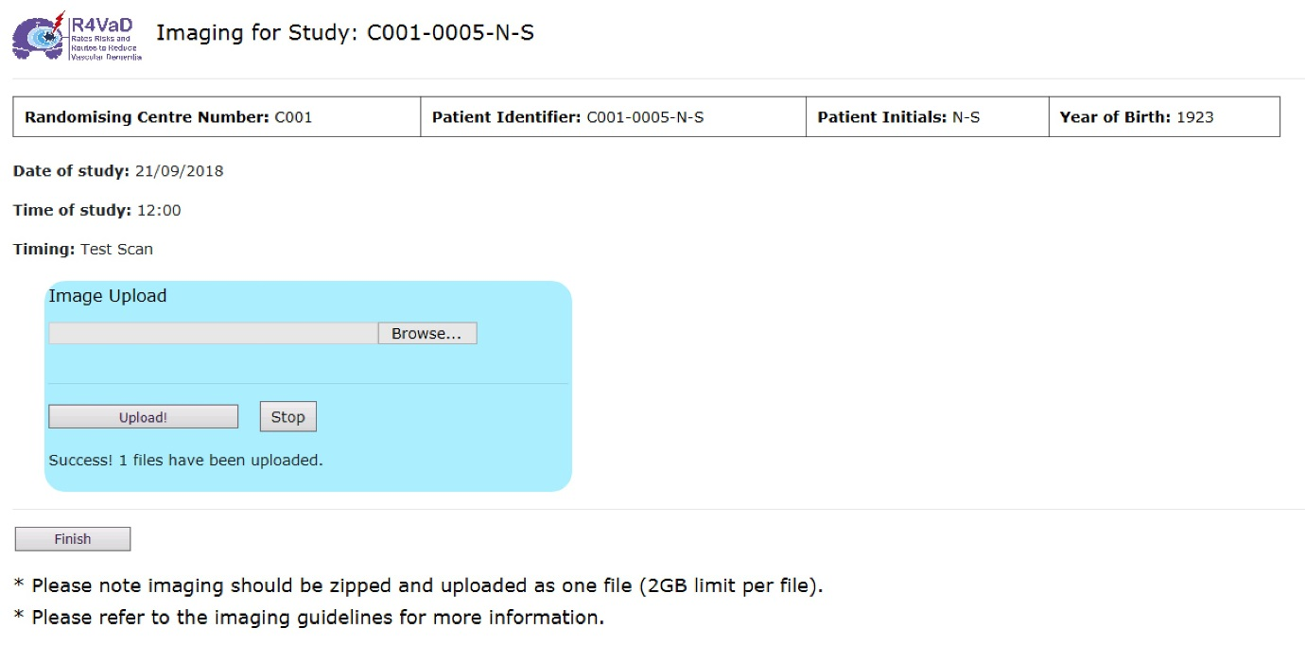

Usually the scan uploading does not take too much time. Sometimes though if the size of the zipped folder is large (**close to the 2GB limit**) and/or the internet speed is not optimal, the uploading can be timed out. The image manager will let you know in the case when no scans have been transferred through in order to repeat the Web Uploading. Select “Finish” to complete the Web Uploading procedure.

**5.2.11** A green tick is next to the “Upload” in the Image Upload box to confirm that the scans have been transferred. You then either select Add New Study to add more scan studies for this patient. Or if you don’t have any other scan studies to upload select “Finish”. If there are no other Scan Studies to upload, log out the R4VaD portal.

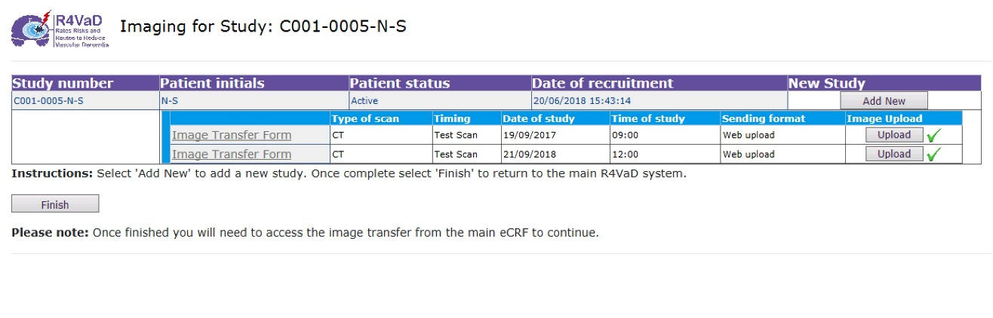

The Imaging Manager has also received an automated notification as an alert that scans have been uploaded.

1. **Help and Queries**

If you have any queries regarding imaging requirements for R4VAD, please contact the R4VaD Imaging Office: by e-mail to: : r4vad@ed.ac.uk or by tel no. +44 131 465 9564.

It is not possible for us to answer all your IT queries so we advise you to make contact with your local IT support personnel and/or PACS manager.

**DOCUMENT HISTORY**

List specified details of previous versions of the procedure.

|  |  |  |
| --- | --- | --- |
| Version Number: | Effective Date: | Reason(s) for change(s): |
| Version 1.0 | 03/10/2018 | Document approved by SM and released |
| Draft 1.0 | 26/09/2018 | Drafted Transfer guidelines to reflect just the uploading procedure. |